‘A Blueprint for Survival’ at 50
What can we learn?
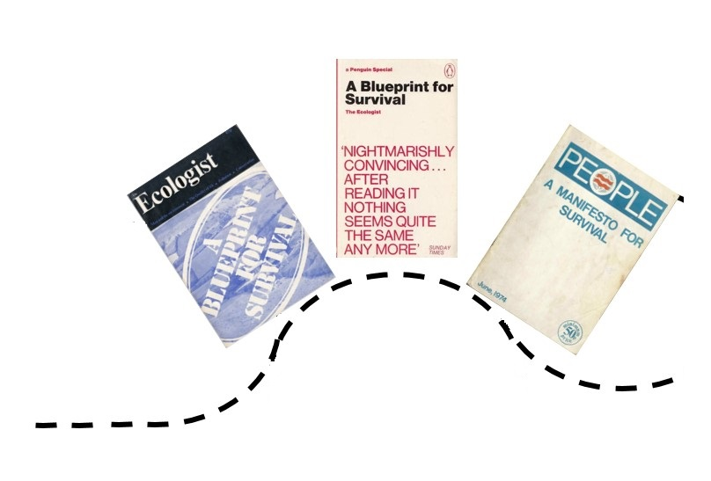An “All Our Yesterdays” report
January 2022

Table of Contents

Executive Summary 3
About All Our Yesterdays 3
What happened 4
Back history 4
UK and global 4
The Ecologist 6
What the Blueprint said 7
What the newspapers (and others) said 7
What happened next (1973-1976) 12
Politically 12
Cultural responses 16
Why was it so? 17
Why should we care?/ What would we have to do differently, if we were saying we had “learnt” from this? 21
Abeyance 22
Absorptive Capacity 23
Arrogance 23
Coda/What is to be done 24
Homework/Some key concepts for you to google 25
Organisations that might be able to help 25
References/Sources consulted/Further reading 26
Appendix: Excerpt from ‘Talking back to Chomsky’ 30
Citation 30

Executive Summary
On Friday 14th January 1972 a bombshell report, ‘A Blueprint for Survival,’ was released onto an increasingly worried world. Produced by the team at The Ecologist, it laid out not just the environmental and social problems, but also offered - the clue is in the name - a blueprint for survival.

Fifty years is a nice round number for reflecting, and this report is designed to help with that.
It explains little of the background to the report - the world it entered, who wrote it, how it was received
It doesn’t go into a great deal of detail about what the Blueprint actually says - read it yourself!
It does however talk about what happened next - what the media response, and the political response was [spoilers - scientists warning of trouble ahead will be derided as scare-mongerers, the public’s attention span is short, it’s really hard to ‘capture the moment’ - to do so you need absorptive capacity up the wazoo].

It then talks a bit about the longer-term, and the birth of the “Ecology Party” (now known as the Green Party), before turning to some of the lessons we might learn around
- Abeyance
- Absorptive Capacity
- Arrogance

Very keen to hear thoughts - either via Twitter or on email - allouryesterdays2015@gmail.com

About All Our Yesterdays
AOY is a website - allouryesterdays.info - and Twitter feed - @our_yesterdays - dedicated to the radical proposition that if “environmentalists” keep doing the same thing over and over and expecting a different result they are… going to be disappointed, and disappointing.
There’s at least one blog post coming for every day of the year, and other resources too (as resources allow).
The project lead is Dr Marc Hudson, with invaluable assistance from Sam Gunsch and Chloe Jeffires.
If you want to help it grow, (and be less eurocentric, among other problems), then please do get in touch, via the allouryesterdays2015@gmail.com

What happened
On Thursday 13th January 1972 a press conference took place. At it the eminent scientist Frank Fraser Darling said it was “the sanest statement on the problems at large that I have seen, a good deal saner than many of the comments in the scientific journals, particularly from America. It is not overdramatic” (Tucker, Guardian 14th January p12). He was talking about “A Blueprint for Survival” (BfS) which he and 32 other eminent scientists and public figures had signed a letter of support about.

In the following days the daily newspapers of the United Kingdom (and other countries) reported the release of a “Blueprint for Survival”, with everything from sedate page 8 in the Times to the one word front page headline in the Manchester Evening News - “Doomed.”

If BfS is remembered at all today, it is probably conflated with another bombshell report that came out two months later - ‘The Limits to Growth’ report of the Club of Rome. Both these are also largely seen by people who did not live through the period (and must be 65 or more) as “one-offs.” However, these reports are more usefully and accurately seen as the culmination of several years of increasing alarm about the damage industrialisation and development - and burgeoning population numbers - were already causing, alongside fears of the direction and speed of travel for both consumption and population (something we will come back to).

This section provides a very brief overview of the context for BfS and the Ecologist magazine.

Back history

UK and global
Concern about localised environmental problems goes back a very long way indeed (see Eisenberg, 1998) The very word sustainability, first used in the modern sense in 1713 by the German Hans Carl von Carlowitz, was in the context sustainable forest management so that mining infrastructure could continue indefinitely (Warde, 2011).

Immediately after World War Two, with the knowledge that man (and I mean man) would probably be able to destroy the planet in a nuclear exchange, two books were published - ‘The Road to Survival’ by William Vogt and ‘Our Plundered Planet’ by Fairfield Osborn - which briefly drew attention to ‘trouble ahead.’

Phenomenal economic growth and technological advances followed though (the so-called “Great Acceleration”) , and the promise was that all problems were susceptible to man’s technology (Hudson wind beneath quote).
Local air quality issues slowly began to be addressed, with the coming of the post-1952 smog event Clean Air Act. Concerns about fall-out (the irradiated crew of the wrong-place-wrong-time and ironically-named Japanese fishing vessel Lucky Dragon 5 gave us that word), pesticides (thanks to Rachel Carson) and strontium 90 in breast milk all created a sense of foreboding, quite aside from the Bomb.

In 1966 the Conservation Society was created in the UK (see Herring, 2001 for a good account of its activities and eventual demise).

It’s hard to understand the emotional impact, now that we’ve become totally habituated to oil spills, but the 1967 Torrey Canyon incident - a prolonged oil spill off the coast of Cornwall - was a very big deal.

The following year saw the publication of Paul and Anne Erlich’s ‘The Population Bomb’ and the famous ‘Earth Rise’ image taken by Apollo 8 astronauts).

Things were moving into higher gear in 1969, with the January Santa Barbara Oil Spill and May’s UNESCO’s Man and Biosphere report. The European Economic Community (without the UK as a member) had a European Year of Conservation, with various Worthy Statements that will be familiar to anyone who opened a newspaper during the recent Glasgow climate conference.

By 1970 the BBC had begun screening “Doomwatch”, and in April co-ordinated protests and teach-ins took place across the USA (“Earth Day”). While politicians created Environmental Protection Agencies (Nixon) and Departments of the Environment and a Royal Commission on Environmental Pollution (abolished in a naked act of vandalism in 2010 by David Cameron), scientists were beginning to take a closer look at carbon dioxide. Carroll Wilson (see Jan 12 blog post on All Our Yesterdays) co-ordinated two crucial reports. To quote -

“Wilson then turned to larger issues, pioneering a new format for studying and publicizing major scientific problems in world development. In 1970, for the first study, he assembled a multi-disciplinary group that produced, in one month, Man's Impact on the Global Environment. The study was an important catalyst of debate within the U.S. on the greenhouse effect and other major environmental consequences of technology, including the SST. The following year Wilson brought together 35 atmospheric scientists from 15 countries in Stockholm to produce Inadvertent Climate Modification: Report of the Study of Man's Impact on Climate.”

Groups like Friends of the Earth and Greenpeace sprang into existence. The BBC ran documentaries like the one on Horizon (8 March 1971) ‘Due to lack of interest, tomorrow has been cancelled’ about Paul Ehrlich and his predictions (see Nancy Banks Smith review).

Internationally the build-up to the June 1972 Stockholm conference was grinding on - many of the debates at the Founex seminar - at which delegates from poor countries pointed out that environmental regulation might be wielded by the West to prevent their economic growth- are being chewed over still (Manulakk, 2016).

In the background, the Club of Rome was putting together, with Jay Forrester, the report that would be known as “The Limits to Growth” (see Turnbull, 2018 for an excellent account of this).

So, for several years, scientists and activists had been talking and doing about the seemingly imminent ‘collapse of everything’ (we should remember that the more lurid announcements were contested at the time, and seen as unhelpful by many, for reasons that are still obvious). It is in this context that the BfS hit the world - or portions of it - between the eyes.

The Ecologist
The magazine had been founded in 1970. According to a 2009 obituary Edward (“Teddy”) Goldsmith
“.... was influenced by the sociological writings of Karl Polanyi, which emphasised the way economies are embedded in society and culture. His travels with his millionaire college friend John Aspinall introduced him to tribal communities on which his later thinking was based. The Ecologist, founded in 1969 and edited by Goldsmith from 1970 to 1989 and 1997-98, was partly financed by his younger brother, James, the billionaire financier” (Schwarz, 2009).

It is of course much more complicated than this - there were other influences and other key players. There’s a lot more about the magazine’s origins at the excellent green-history.uk website. Specifically on the origins of the Ecologist and BfS, see Taylor, 2017.

What the Blueprint said
You should read the thing. It’s well-written, bracing and “scary AF” as the young people used to say.
The short version is this -
- Economic Growth should not be a thing, can’t go on
- Population Control should be a thing [in both senses]
- Raw materials will probably run out
- Roads and Motorways are Bad
- Centralisation leads to all kinds of pathologies and we’d all be better off in much smaller-sized political units.

What made the report particularly weighty was that 32 scientists had put their names to a statement of general support. Most have not survived posterity, but several are worth mentioning.
Peter Scott was a kind of hybrid of David Attenborough, Chris Packham and George Monbiot.
Julian Huxley was an extremely eminent evolutionary biologist
EJ Mishan was an economist who critiqued ‘the diseconomies of growth’

What the newspapers (and others) said
A full accounting of the print media response to BfS is beyond the scope of this report (and the boredom threshold of the author, for now at least), but the following will do for now.

The Guardian barely covered it at all on the day (with science correspondent Anthony Tucker optining instead to cover the grumpy statement of Nature editor John Maddox.

The Telegraph reported, on page 2 “Leading scientists urge today the setting up of a national Doomwatch movement to prevent the self-destruction of mankind,”.
Presaging the “they-can’t-predict-the-weather-what-would-they-know about-the-climate” arguments of later years they editorialised the following day: “It is unlikely that scientists can forecast with any greater precision than economists and sociologists the interaction of forces that shape civilised society. As natural resources become scarce and costs rise the search for substitutes is automatically intensified to postpone the day of reckoning. The world may not end tomorrow.”

The Daily Mirror had nothing on the day itself, but the following day the front page was “Doomwatch Poison Test” about some presumed-dumped barrels of cyanide.

The Daily Mail was more forthcoming. Its environment correspondent, John Stevenson, wrote “The document sets itself an ambitious target. Perhaps too ambitious. For while it brilliantly outlines social and environmental problems confronting an ever-industrialised society like Britain, its solutions are too frequently vague, and too often meaningless. Because of the urgency of these issues the Daily Mail analyses the report and invites comment from the public.”

The Mail’s editorial concluded that “we live in a world where our instinct for survival has yet to curb our greed. At such a time, surely the prophets of doom deserve to be heard with as much respect as those who continue to worship the Gross National Product.”

This may be slightly surprising to modern readers.

Similarly the Times editorialised that “the thesis is too plausible to be dismissed. It has been edging its way into the universe of popular debate for some time now. “A blueprint for survival “ puts it in a convenient and cogent form which firmly fixes its political relevance.”
Its front page story had led with the point that the Movement for Survival “say that if necessary the movement will have to assume political status and fight the next general election.”

One is reminded of the classic joke (see quote below) which I am pretty sure popped up in a slightly different form in Joe Ashton’s 1977 novel Grass Roots. But anyway, here’s the Yes Prime Minister version, with Prime Minister Jim Hacker explaining how it works.
Hacker - “Don't tell me about the Press. I know *exactly* who reads the papers. The Daily Mirror is read by the people who think they run the country. The Guardian is read by people who think they *ought* to run the country. The Times is read by the people who actually *do* run the country. The Daily Mail is read by the wives of the people who run the country. The Financial Times is read by people who *own* the country. The Morning Star is read by people who think the country ought to be run by *another* country. The Daily Telegraph is read by the people who think it is.'
Appleby- "Prime Minister, what about the people who read The Sun?"
Wooley - "Sun readers don't care *who* runs the country - as long as she's got big tits.”

Punch had a handy “here’s how different groups will respond”. I won’t reproduce the whole thing (copyright and all that, but this gives a taste).

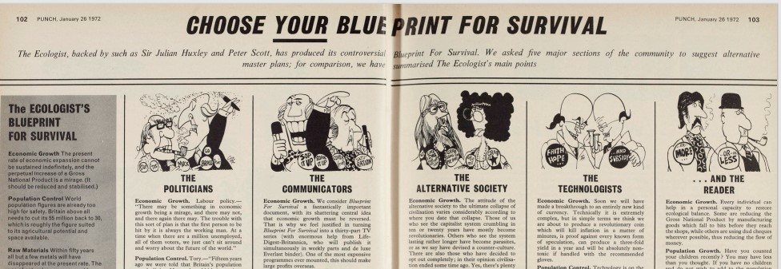

More entertaining still is the response of Nature and New Scientist. There was a fulminating Nature editorial ‘The case against hysteria’ by John Maddox, whose book ‘The Doomsday Syndrome’ was published a few months later. Seriously, it’s semi-unhinged. Amidst potshots at other targets, it said of BfS that it “reflects and sometimes amplifies a good many of the half-baked anxieties about what is called the environmental crisis” and continued in that vain - sorry - vein - for two more pages.

Two signatories of the 33 scientists wrote to Nature in the following weeks.

Aubrey Manning concluded his short letter with the free advice - “It is surely your duty, both to the scientific community and to the society at large, to marshal and present in extenso the evidence which leads you to dismiss the arguments in "Blueprint for Survival".

In the same issue a non-signatory, SRJ Woodell, said that the editorial
“does little credit to a distinguished journal from which one expects impartial and well balanced assessments of scientific and social problems…. You, Sir, appear to think that the problem will cease to exist if you bury your head in the sand. A more constructive discussion of these problems in your columns would be very welcome.”

On 28th January CJ Waddington observed that Maddox, in “commenting on the Blueprint for Survival, you made heavy calls on your resources of invective, but few or none of your stocks of factual information.” Those, among scientists, are fighting words.
Waddington makes a point which is sadly still relevant today

“I suggest that, to the scientific public, a greater danger of misjudgment arises from what one might call a "hysteria of complacency". Is it good enough to dismiss, say, the population problem by the argument that it is not very pressing in Britain-so long as protein foodstuffs for man and beast are available at reasonable prices on the world market, which may well not be so for very long? Can one dismiss pollution, or exhaustion of easily won raw materials, because one could surmount these impediments by paying enough - if the economic system allowed? “

New Scientist broadly approved of BfS
“This document is an important environmental text, ranking alongside Rachel Carson's Silent Spring and the SCEP study Man's Impact on the Global Environment (MIT Press, 1970). Unlike many previous publications from The Ecologist, which have shown a depressing belief in the theory that facts can be left to take care of themselves provided the heart is in the right place, Blueprint for Survival is in the main sober, restrained, accurate and convincing.”

Its editorial, entitled “Ostriches” chided both Nature and the Telegraph for their coverage, presaging James Hansen’s more recent warnings of the dangers of scientific under-estimation of environmental problems (what Hansen, 2007 calls ‘scientific reticence’; see also Bradshaw et al. 2021).

“The ostrich view was neatly summarised in a Sunday Telegraph leader (16 January): "The trouble about these prophecies of doom is that they suggest a prospect so awful, and one that would require such hideously dangerous efforts to avert, that people refuse to take the warnings seriously." In other words, where compromise and accommodation become a political way of life, they engender the belief that any analysis demanding a more rigorous solution must automatically be erroneous. The same view underlies the less restrained comment of Nature (vol 235, p 63) on the Blueprint.”

Within a couple of months, another report, with computer models this time, was released - ‘The Limits to Growth.’ The academic response to both these reports, but especially the latter, is captured by the notorious “Malthus with a computer” jibe by the Science Policy Research Unit of University of Sussex , which glancingly refers to BfS as “doomsday literature” (Freeman, 1973, p.9.). More on this another time, perhaps: Full disclosure, they gave me my dream job recently.)

“A similarly conservative criticism of growth can be seen in the reception of the MIT proposals in Britain, voiced in particular in the journal The Ecologist. Founded in 1970 by the philosopher and economist Edward Goldsmith, The Ecologist addressed Forrester’s arguments and those put in The Limits to Growth, of which, it seems, it had received advance copies, in its issue Blueprint for Survival of January 1972.

In doing so, the journal regarded itself as the ‘national movement’ of the Club of Rome…. It used the book’s arguments to develop its own future scenario, but its conclusions went far beyond those of The Limits to Growth. The MIT team’s computer simulations had shown that the ideology of growth and the consumer mentality had led to environmental pollution and shortages of raw materials, with the result that the breakdown of society was inevitable. The only hope, it claimed, lay in a stable or sustainable society where people looked after themselves in small communes and recycled materials, with an authoritarian state imposing population controls.

The parallels with Gruhl are obvious. Distributed with the Blueprint for Survival was an appeal for a Movement for Survival signed by well known British scientists and conservationists such as Julian Huxley. This was the starting point for the founding of the People Party, predecessor of the later Green Party.

Initially, the Movement for Survival was supported by the environmental groups Conservation Society and Friends of the Earth. Both had been created as part of the modern environmental movement in the late 1960s. Unlike the established nature conservation organizations (such as the Royal Society for Nature Conservation and others), they used direct action to pursue their interests and were inspired by the practices of civil society. But they also worked within the system.61 To this extent, their aims did not go as far as those of The Ecologist. The Conservation Society referred to The Limits to Growth when proposing a limit on consumption. It voted in favour of a ‘sharing and rationing of the scarcer nonrenewable resources’ and supported a governmental campaign to influence consumer appetites and a shift in the emphasis of employment from manufacturing to services” (Seefried, 2011, 20-1).

What happened next (1973-1976)
As Taylor (2017) notes
“Blueprint for Survival become a best-seller, selling 750,000 copies worldwide, being debated in the House of Commons and serving as inspiration for many Green manifestoes, including Blueprint for New Zealand in May 1972 and, in the UK, PEOPLE’s Manifesto for Survival in June 1974.”

In this brief section I’ll pick out two strands - politics and culture. In the final section I will ask what we can learn from it all.

Politically
After laying out the Blueprint, the Ecologist folks had declared the creation of a “Movement for Survival”, right there on page 23.

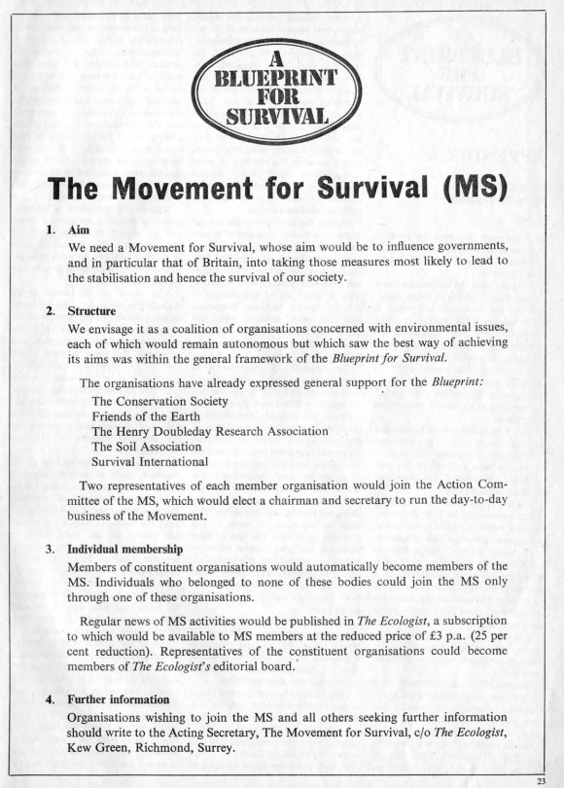

As the website Green-History.UK notes
“Although not formally a political party it was the first organisation in the world to publicly organise for political action on ecological grounds.” Another page quotes Michael Allaby as saying “After the Blueprint appeared things were pretty chaotic for a time. It’s no wonder letters received no replies - there was no one to write them!”
It observes that “Movement’s failure as a separate organisation was simply that it lacked the organisational capacity to respond to all these letters and turn the initial enthusiasm into an effective national organisation.”
Meanwhile, another group of people was active. According to Rudig and Lowe (1986: 269)
“An article by Paul Ehrlich in Playboy [in August 1971] attracted the attention of several solicitors and managers who together were arranging to place a major manufacturing company in receivership. A series of meetings took place [in Coventry] with a number of friends, to discuss the ‘ecological crisis’. Several options were explored, and at the end of 1972 the group dispersed with its members having come to different conclusions: some thought political action was fruitless, some joined environmental pressure groups such as the Conservation Society. A core group of four people, however, concluded that the only adequate response would be a new political party. They were Tony and Leslie Whittaker, solicitors, Michael Benfield, an estate agent, and Freda Saunders, his assistant. With the exception of Tony Whittaker, who had previously been a Conservative councillor, this appears to have been their first political activity.”

On the Green-History UK website, one of those involved, Lesley Whitaker, recalls
“When we eventually took over Movement for Survival, Teddy told us that the Ecologist staff had not even looked at any of the replies. They were just in open cardboard boxes in which the torn-out back pages were dumped. The move of The Ecologist and its people to Cornwall had been a major distraction, and there was barely enough of an organisation to run the growing Ecologist, let alone handle the huge swell of interest the announcement of MfS had generated. I think they were all amazed and rather scared by the scale of the success.”

Rudig and Lowe (1986:266) write
“The Ecology Party was founded under the name ‘People’ in Coventry in February 1973. It was not very active in the first few years and the small membership grew only slowly (see Figure 1). The first phase of Party development lasted until 1975. It comprised various unsuccessful attempts to attract the environmental movement to the Party; the fielding of five and four candidates respectively in the general elections of February and October 1974; the first national Party conference in 1974 which passed a Party manifesto and the second in 1975 which formulated a political programme. Its electoral performance proved disappointing (see Table 1) and membership remained very small. Strong ideological differences emerged at the 1974 and 1975 conferences and several leading members of the Party either resigned or withdrew from active involvement.”

In his obituary of Goldsmith, Schwarz (2009) recalls that
“[Goldsmith] began campaigning, in flamboyant style, in the February 1974 general election when he stood as the People party candidate at Eye, Suffolk. In protests against intensive farming which degraded the soil, he and his supporters paraded with a camel borrowed from Aspinall's private zoo, bearing the slogan "No Deserts in Suffolk. Vote Goldsmith." Few people did, he lost his deposit and retreated to a Cornish village from where he edited the Ecologist until 1989 “(Schwarz, 2009).

But things did not go well straight away. Interviewed in January 1972 by the Sunday Telegraph, Goldsmith had said
“Up to now, politicians here have given the problem only piecemeal attention because there aren’t many votes in it - yet. But, “ Goldsmith added with an apocalyptic smile, “there will be. Oh yes, even in three years’ time, there will be” (emphasis in the original)” (Mandrake, 1972 - emphasis in original).

It was not to be. Rudig and Lowe, 1986) note that

“The year 1975 marked an important turning point for the Party. For the Right, the failure of the Party to make an impact at the 1974 elections and its total isolation in British political life raised strong doubts about its ability to avert the still-expected catastrophe. Tony and Leslie Whittaker, having sold their legal practice in Coventry, moved to Devon to become smallholders and withdrew from national activity. On the Left, there was a growing concern that the Party had too many authoritarian-minded elements. Dr Peter Allen’s decision to resign was finally precipitated by personal conflicts. The exodus of key members coincided with a sharp decline in public interest in issues such as the limits to growth and the population explosion. Organizations concerned with these issues, such as ConSoc and also The Ecologist experienced great difficulties maintaining their appeal; and the small Ecology Party came close to extinction” (Rudig and Lowe, 1986, emphasis added).

Cultural responses
There were already other eco-novels and movies out there, (The Sheep Look Up, Soylent Green etc), but time - like our species’ future - is short, so I will save all this for another time.

In direct response to BfS, the producer of the BBC television show “Doctor Who”, Barry Letts and the script editor Terrance Dicks wanted a response. The following year saw Jon Pertwee’s Doctor travel to Wales and investigate lethal green sludge, chippy miners and an Evil Multinational Company (This is ‘Doctor Who and the Green Death,’ the one with the miners, the hippies, the Mad Computer and the giant maggots and giant fly. Fwiw, the novelisation of this, by Malcolm Hulke, was hugely influential on the author). The Green Death led in turn to a story the following year scripted by ex-communist Malcolum Hulke, called Invasion of the Dinosaurs (the one with terrible models of dinosaurs battling it out in an evacuated London). (For more on these, see Jørgensen, 2012; Orthia, 2011)

The “end of the world” vibe continued on British TV with Terry Nation’s ‘Survivors.’

The whole ‘back to the land’ thing got spoofed/lovingly pisstaked in ‘The Good Life’ which - sit down all you Doctor Who fans - probably had more cultural impact. [A great novel that should have won the Booker Prize (and would have but for Harold Wilson’s wife), check out the late Julian Rathbone’s ‘Kingfisher Lives.’]
But on the whole, the urgency of that period 1969 to 1972 would not return until 1989. And then again in 2006, and then again in 2018/9. And on each occasion it lasted three or so years, before vanishing like a fist when you open your palm. Maybe it will be different this time. We shall see.

Why was it so?
Surely everyone, once they know The World Is About to End, drops what they are doing, and all their bad habits, and fights with every fibre of their being to avert the apocalypse? Not, I hope we can all agree, so.

When it comes to disaster studies (yes, a thing), there is an ‘Elite Panic’ model, where elites assume (wrongly) that there will be looting and violence in the aftermath of a natural disaster if there isn’t a strong security response. No matter how many times this is proven to be false, it persists, and not only because of kickbacks from fat contracts for security kit.
There’s a mirror image false belief that an emergency leads, by itself, to sustained and strategic civil society engagement. No matter how many times this is proven to be false, it persists.

So why did the eco-movement not thrive?

For one thing, there was a lot else going on.
The end of 1973 saw an enormous oil price rise, imposed by OPEC in the aftermath of the Yom Kippur War, stagflation and the end of the post-War Keynesian settlement. (But there are always external factors.)

There were the usual ideological splits. Rudig and Howe (1986 271) note that
“Among the new recruits had been a group of students and younger people from Liverpool and Leeds, who soon found themselves embroiled in ideological conflict with Edward Goldsmith and the Coventry founder members. The Party’s main ideological inspiration had come from Edward Goldsmith’s writings which set out a fairly comprehensive theory of social evolution and industrial society. Industrialism for him led to the increasing ‘disintegration’ of society. Goldsmith’s counter-idea of an ecology society implied the resurrection of the authority of family and community, supplemented by a ‘unified science’ which would provide the basis for planning and directing the society. His sophisticated theory, which is too complex to explore in greater detail here, led to a number of policy proposals rejecting women’s emancipation and the integration of foreigners, strengthening law and order, and courting the idea of strong authoritarian government. The Left, mainly represented by Dr Peter Allen, a geologist from Leeds, rejected these policies and the general philosophy behind them. While accepting the thesis that survival was at stake and wanting to stop further industrialization and urbanization, the Left did not want to go as far as a total rejection of industrial society; feminism should be supported, foreigners integrated, education maintained. A gradual change, providing for basic needs for everybody, bringing industry into co-ownership and dispersing the multinationals, was foreseen as the means of avoiding cataclysmic change.”

Meanwhile, (Gartforth. 2002, p.101-2) nails it.
“In retrospect, many aspects of the Blueprint for Survival seem anachronistic. Like The Limits to Growth itself, the explicit radicalism of its programme is often undercut by the implicit suggestion that the changes it prescribes might be effected within the existing structures of modern capitalist institutions. " Economically, its assertion that it might be possible to change from an "expansionist society to a stable society without loss of jobs or an increase in real expenditure" (Goldsmith et al, 1972, p8) speaks volumes about its failure to identify or address the material power structures of industrial capitalism. Socially, many aspects of The Ecologist's vision of a secure, ecologically sustainable society feel staid and reactionary, compared to the currents of new social movement and new left libertarian politics that have been embraced by later ecocentric thinkers. It is built on the unarticulated assumption that the nuclear family must function as the undisputed centre of social life. This in turn connects with the more overt and unreflexive desire for a return to mechanical forms of social solidarity - with their full implications of coercive social control. Rhetorically, a manipulative paternalism suggestive of the Brundtland Report pervades the Ecologist's arguments, most marked in relation to its discussion of population control where "subtle cultural controls" are advocated in order to "inculcate a socially more responsible attitude to child-rearing" (The Ecologist, 1972, p14; my italics).

“Perhaps the greatest contradiction that the Blueprint displays is the stark contrast between the new forms of society it advocates and the projected transition from industrialism to sustainability. Its model of a sustainable future is open, radically democratic and bottom-up, evoking the possibility of a revolution in values and the meaning of human well-being and satisfaction. Its model of change however, owes its greatest debt to the economic realism of discourses of 'efficiency'; its assumptions are technocentric and its aspirations managerialist.”

[For a discussion of where all this comes from, see Pepper, (1984).]

So what else is going on? Why do we keep getting these spasms of attention, followed by (relative) ignoring and ignorance?

You can look at it from a moralistic/individualistic level, and say something like
“It turns out thinking about the size and scope of the horror is hard. Nobody can stare into the abyss very long…. Mumble mumble, oh what’s that quote by TS Eliot what will make me sound all educated and cultured - quick google - ‘Humankind cannot bear very much reality.’”

You can take a slightly more sociological point of view, and point to the human tendency to become exhausted/bored with problems that don’t have ready solutions.

You can point to the media’s insatiable need for novelty and to keep people in a (new) level of anxiety. As Cook (2022) astutely observes -
“The corporate media is not our friend. The aim of its coverage of the pandemic is not to promote the public good. It is there to feed our anxieties, keep us coming back for more and monetize that distress.”

If you’re feeling even more sociological, and looking to blame someone else, you can use that media analysis to explain (away) the difficulty faced by social movements in sustaining their pressure (“hippies do crazy photogenic thing X” is a story once or twice, but rather like a spider whose web you poke, they learn not to take the bait).

Obviously I don’t think that’s enough of an explanation. I think we need to look at the massive propaganda efforts to confuse people about the causes and consequences of environmental degradation, alongside the more overt campaigns of violence (fast, slow, everything in between) by states and corporate actors [it is often hard to tell where one ends and the other begins] against social movements, trade unions and others who would try to make things less ecocidal.

And we need to look at how social movement organisations have real issues to face around recruiting and retaining members. They need project management skills, volunteer management skills, patience, time at levels far beyond what they have, or - sadly - could reasonably be expected to attain. And any individual group that somehow got hold of and kept all these would need to be part of a functioning ecosystem of groups, with an at least intermittently responsive political and economic system with which to interact. So, um, oops.

Why should we care?/ What would we have to do differently, if we were saying we had “learnt” from this?
We’ve just been through an “Up like rocket and down like a stick” experience between 2018 and 2021. There will be a residue from that (but how much, well, who knows, and it still depends on what actions individuals and organisations take in the coming months).

First, I am going to say again, Blueprint for Survival mattered, in ways it intended and ways it didn’t. As Callaghan (1990) recaps,

“Blueprint For Survival in 1972, a manifesto of Green ideology which stands as one of the foundation documents of the movement and the direct inspiration for the formation of Europe's first Green Party, 'People' in 1973 (restyled the Ecology Party in 1975 and known as the Green Party since September 1985). The main contention of the new party, which has been constantly reiterated by succeeding versions of its Manifesto For a Sustainable Society, is that 'continued industrial expansion . . . is not sustainable and its termination on a universal scale is likely within the lifetime of someone alive today'” (Callaghan 1990).

By now we should have known that the information deficit model - of putting “The Facts” in front of people - might lead to a brief mobilisation, but it won’t on its own, create long-term structures that can keep making moves to stay in the ‘game.’ Turns out the things are going from bad to verse (John 8:32, since you ask) but the biggest truth is that the Truth won’t set you free.

Three things of the things we can take from the BfS experience are (drumroll please)

“The triple AAA battery of the ‘movement’”

- To understand abeyance - where it comes from, what to DO about it
- Absorptive capacity - why it matters, how to get it, keep it
- Arrogance - where it comes from, why it matters [in a bad way] and what to do about it.

Abeyance
Abeyance means “a state of temporary disuse or suspension.” Maguire (1992) has the best title on this - “When the streets begin to empty: The demobilisation of the British peace movement after 1983”

It’s gonna be tough for those who are still trying to “do stuff,” even if it is in that theme park that Bluhdorn (2006) writes about. There are issues around demoralisation, survivor guilt, exhaustion, recriminations and resentment, you name it. If they’re not acknowledged, contained, processed, they get radioactive/toxic/you-name-it.

(See also - Hudson, 2019; Jeffries, 2022)

Absorptive Capacity
Back in the day, I pinched this term from business studies. Basically, it asks - can an organisation (a business) spot an opportunity (a new technology, a new process, new staff) and harness the energy/opportunity? Or is it stuck in its existing rituals and patterns?

Absorptive capacity is one of several basic problems for small groups (and big ones), specifically: being able to regularly provide - via clear communications - simple but meaningful jobs to new people which are not a) too difficult or too easy and are also not mission critical. If a group doesn’t consistently maintain this practice, chances are people will not stick around (there are a huge number of other reasons why people won’t stick around). You also have to deal with people not doing stuff, and making sure that the tolerance of this does not mean other more committed folks don’t get pissed off, without enabling competitive martyrdom. It’s not easy. If it were easy, we might not be in this horrendous mess.

What groups that still exist might usefully think about how to develop their absorptive capacity for the next wave of environmental concern (and it may be that this one, which “peaked” with Glasgow never really goes away? Dunno).

Arrogance
The aforementioned Malcolm Hulke did a brilliant job with his novelisation of the “Invasion of the Dinosaurs.” There are several choice quotes, but this one will do….

“We had to clear London so that undesirable people, people not approved by us as right-thinking, wouldn’t be taken back through Time with us.” (Hulke, 1976)

I am only gonna flag this, because I am the last person who should be offering anyone any advice about avoiding arrogance.

Coda/What is to be done
Well, obviously publicise this report and get involved in the project - “All Our Yesterdays” - it is part of.

Discuss the concepts of abeyance, absorptive capacity and arrogance.

A lot of what I’ve taken above comes from “elite” sources - mass media, scientific and academic journals. That’s fine, but those folks do not have a monopoly on worthwhile knowledge (Bacevic, 2021). Continuing to act as if they do has contributed to us not getting out of the mess that Blueprint for Survival told us - 50 years ago - that we should [there are other, bigger factors at play - for another time]. So, the last word in this report is reserved for a wonderful publication called Peace News, which is still going and deserves your attention and support. Their correspondent Ben Crowe at a Conservation Society event (see also Nature for an account) used words from “Friends of Ehrlich.”
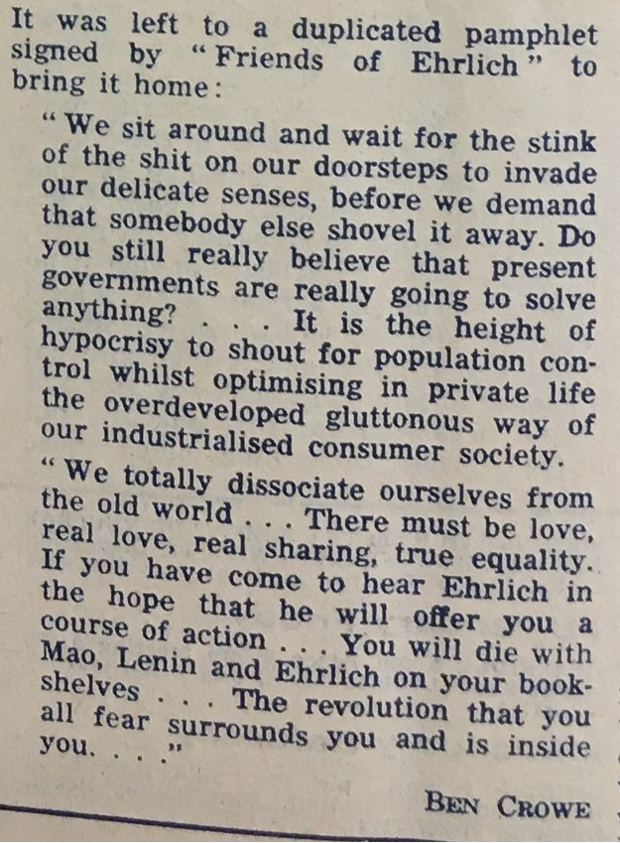
“We sit around and wait for the stink of the shit on our doorsteps to invade our delicate senses before we demand that somebody else shovel it away. Do you still really believe that present governments are really going to solve anything? … It is height of hypocrisy to shout for population control while optimising in private life the overdeveloped gluttonous way of our industrialised consumer society.
“We totally dissociate ourselves from the old world. There must be love, real love, real sharing, true equality. If you have come here to hear Ehrlich in the hope that he will offer you a course of real action… you will die with Mao, Lenin and Ehrlich on your bookshelves. The revolution that you all fear surrounds you and is inside you…”

The modern version would presumably be something along the lines of “Monbiot, Chomsky and Mann) on your bookshelves”?

I don’t think anybody is likely to be writing “Blueprint for Survival at 100” - I hope I am wrong.

Homework/Some key concepts for you to google
Impact Science
The “Malthusian Moment”
Millenarianism
Post-ecological politics
Production science

Organisations that might be able to help
This is where I am weakest. I don’t know: it seems quite beyond salvation. There are many many groups out there explaining that the cat should wear a bell. But a lot fewer organisations that have been putting the bell on the cat, and explaining how other mice can do likewise (or, in the wise words of Cynthia Peters trim the beast’s toenails(appendix)).

I’d be “happy” to do a second edition with details of long-lived organisations with a proven track record of effectiveness.

In the meantime, if you live, work or study in Manchester, the folks over at Climate Emergency Manchester, which I co-founded but am no longer part of, would love to hear from you.

References/Sources consulted/Further reading
Agar, J. and Wood, J. (eds) (2018) Histories of Technology, the Environment and Modern Britain. London: UCL Press - https://www.uclpress.co.uk/products/87840

Anon (1972) "Warning bells ring on space-ship Earth." Daily Mail, 14 January, p. 6.

Anon (1972) "The Prophets May Be Right." Times, 14 January. p.13

Anon (1972) Our Environmental Correspondent. "Leading scientists call for ‘drive to save mankind’." Daily Telegraph, 14 January p. 2

Anon (1972) Doomwatch. Manchester Evening News, 15 january, p1

Anon (1972) "The Doomwatchers." Daily Telegraph, 15 Jan. p. 16.

Anon (1972) "To the Point - shock tactics." Sunday Telegraph, 16 Jan, p. 20

Anon (1972) Many show interest in Doomwatch The Guardian Jan 15, p16

Anon (1972) ENVIRONMENT The Third Coming. Nature Vol 235, Jan 21 p.119

Bacevic, J. (2021) Unthinking knowledge production: from post-Covid to post-carbon futures. Globalizations, Volume 18, 7: Economics and Climate Emergency https://doi.org/10.1080/14747731.2020.1807855

Banks-Smith, Nancy (1971) Horizon on Television. The Guardian, March 9, pg. 8

Beale, N. (1972), et al. "Ecology." Economist, 4 March., pp. 4

Bluhdorn, I. (2006) Self-Experience in the Theme Park of Radical Action?: Social Movements and Political Articulation in the Late-Modern Condition. European Journal of Social Theory.
https://doi.org/10.1177/1368431006060461theme park of radical action.

Bradshaw et al. (2021) Underestimating the Challenges of Avoiding a Ghastly Future Front. Conserv. Science https://doi.org/10.3389/fcosc.2020.615419

Callaghan, J. (1990) The greening of British politics, Contemporary British History, 4:2, 2-5, DOI: 10.1080/13619469008581111

Connew, P. and Ricketts, R. (1972) Doomwatch Poison Test. Daily Mirror, 15 Jan, p.1

Cook, J. (2022) Covid’s lesson: When anxious, isolated and hopeless, we’re less ready to think critically. JonathanCook.net 6 January.
https://www.jonathan-cook.net/blog/2022-01-06/lesson-covid-critical-thinking/

Crowe , B. (1972) you will die with mao, lenin and ehrlich on your bookshelves. Peace News 21 jan, p.10

Eisenberg, E. (1998) The Ecology of Eden. New York, Alfred a Knopf Inc)

Freeman, C. (1973) Malthus with a computer. Futures, 5-13
Garforth, L, (2002) Green utopias: imagining the sustainable society. PhD thesis, University of York

Georis, R (1972) "Man's future." Economist, 26 Feb., p. 8.

Hansen J. (2007) Scientific reticence and sea level rise. Environmental Research Letters, Volume 2, Number 2 http://dx.doi.org/10.1088/1748-9326/2/2/024002

Herring, H. (2001)The Conservation Society: Harbinger of the 1970s Environment Movement in the UK . Environment and History, Vol 7, 4, pp. 381-401(21) doi.org/10.3197/096734001129342522

Hudson, M 2019 The January 4th, 2023 problem. Climate Emergency Manchester, 12th June https://climateemergencymanchester.net/2019/06/12/the-january-4th-2023-problem/

Hulke, M. (1976) Doctor Who and the Dinosaur Invasion.

Jacob, C. (1972) "Choose your Blue Print for Survival." Punch, no. 6856, 26 Jan., p. 102-103.

Jeffries, C. 2022 Can green groups survive abeyance? All Our Yesterdays 4th January https://allouryesterdays.info/2022/01/04/2023-jan-4-can-green-groups-survive-abeyance/

Jørgensen, D. (2012) A Blueprint for Destruction: Eco-Activism in Doctor Who during the 1970s. Ecozone, Vol. 3, No 2.

Leach, G. (1972) The Alternative Future Spaceship Earth. The Observer Jan 16, pg. 8

Lister, J. 1972 Prophets of Doom - or is there Hope? New England Journal of Medicine.April 27, pp.927-8.

Maddox J. (1972) "Population and world resources." Times, 18 Jan., p. 13.
(Also wrote a book)

Mandrake (1972). "A united front for survival." Sunday Telegraph, 16 Jan. 1972, p. 11.

Maguire, D. (1992) When the streets begin to empty: The demobilisation of the British peace movement after 1983. West European Politics Volume 15, Issue 4 https://doi.org/10.1080/01402389208424933

Manulak, M. (2016) Developing World Environmental Cooperation The Founex Seminar and the Stockholm Conference

Orthia, L. (2011) "Paradise is a little too green for me": Discourses of environmental disaster in 'Doctor Who' 1963-2010. Colloquy Issue:21 [56]-80

Pepper, David (1984) Roots of Modern Environmentalism. Routledge

Peters, C. (2004) Talking back to Chomsky. Znet, 26 April.
http://www.archive.kubatana.net/html/archive/opin/040426cp.asp?sector=CACT&year=2004&range_start=31

Platt, J. (1973) Review: Movement for Survival’ Science, Vol. 180, No. 4086 (May 11,. 580-582: https://www.jstor.org/stable/1736162

Rudig, W. and Lowe, P. (1986) The Withered ‘Greening’ of British Politics: A Study of the Ecology Party. Political Studies, Vol 34, pp.262-284
https://doi.org/10.1111/j.1467-9248.1986.tb01595.x

Schwarz, W. (2009). Obituary: Edward Goldsmith. The Guardian, 27 August.
https://www.theguardian.com/environment/2009/aug/27/obituary-edward-goldsmith

Seefried, E. (2011) Towards The Limits to Growth? The Book and its Reception in West Germany and Britain 1972–73 German Historical Institute London Bulletin, Vol 33, No. 1, pp 3-37

Stevenson, J. (1972) "Blueprint for survival." Daily Mail, 14 Jan, p. 14-15.

Taylor, D. (2017) green history-uk website. https://green-history.uk/

Thompson, J. W. M. (1972) Where those Doom prophets go wrong." Sunday Telegraph, 4 June, p. 7

Todd, l 1972 Prophets and doom The Guardian Jan 26, pg. 12

Tucker, A. (1972) Disaster-mongers 'cause for alarm' The Guardian Jan 14, pg. 8

Tucker, A. (1972) Survival kit: Anthony Tucker on a lifesaving document The Guardian Jan 14, pg. 12

Turnbull, T. (2018) Simulating the global environment: the British Government’s response to The Limits to Growth In Agar and Ward (eds): Histories of Technology, the Environment and Modern Britain
https://ucldigitalpress.co.uk/Book/Article/53/78/3953/

Veldman, M (1994). Fantasy, the Bomb, and the Greening of Britain. Cambridge University Press . ISBN 978-0521440608.

Wall, D. (1994) Weaving a Bower Against Endless Night: An Illustrated History of the Green Party. Green Party.

Warde, P.. (2011) The invention of sustainability. Modern Intellectual History, 8(1), pp. 153–170.

Wilson, M. (2018) Doomwatch and the Environment in Britain, 1970-c.1974. French Review of British Studies. https://doi.org/10.4000/rfcb.2621

Wright, P 1972. "Scientists may fight election over environment." Times, 14 Jan., pp. 1-2

Appendix: Excerpt from ‘Talking back to Chomsky’

This below is a portion of Peters (2004) Talking back to Chomsky. Znet, 26 April.
http://www.archive.kubatana.net/html/archive/opin/040426cp.asp?sector=CACT&year=2004&range_start=31
The Strategy Problem
“But maybe you decide to be an activist anyway. The beast is man-made, after all. If we created this thing, we ought to be able to take it apart. Maybe you are wrong, not about how small you are in relation to the beast (because there's no changing that), but in your assessment of how much power you have or might have, especially if you join with others.
“So you start looking around. Citizens have been studying how the beast works, and they notice when it stretches out its claws, it hurts people, kills them, displaces them, leaves them unable even to subsist. You see that various groups are working desperately to mobilize a small handful of people to get the resources together to trim one toenail of our multi-clawed beast. This would ease the pain and suffering of the people who come into contact with the claw.
“It barely seems reasonable to engage in this activity given the potential ferocity of the limb to which the nails are attached, but you are human and you see people will benefit at least a little by less sharp claws, so you are moved to join the effort.
“But, wait, people are fighting about which toenail it would be best to trim and since they can't agree, they have split up and are now competing for toenail trimming resources. You hadn't been sure in the first place about whether toenail trimming would be all that effective, especially as the tail swishes, and the exhalations continue unabated, but now you see that you probably won't even accomplish the toenail trimming since there is so much disagreement about which toe to tackle.”

Citation
Hudson, M. (2022) ‘A Blueprint for Survival at 50: what can we learn? All Our Yesterdays, 14 January. allouryesterday.info

Full disclosure - I think there’s probably an untold (or unknown to me) story about the Swedish influence on creating a sense of global eco-alarm. It was their initiative to hold the June 1972 summit about environmental concerns, and Bert Bolin was already worried about C02 build-up.

