Submission to

Select Committee on Information Integrity on Climate Change and Energy

V 1.0
September 2nd 2025.

Bio 4
Australian climate awareness 5
The “denialist” lobby and its favoured tactics 11
Favoured tactics 11
Forms of climate denial 11
Disinformation and Misinformation tactics used 12
Useful academic and non-academic concepts (in alphabetical order) 14
Anti-reflexivity 14
“Impact Science” versus “Production Science” 14
Production science 14
Impact science 14
Kayfabe 15
Petro-masculinity 15
Further reading on petromasculinity 15
Reflexive Modernisation 16
Settler colonialism 16
Spiral of Silence 16
Recommendations 16
Expect the denialist lobby to (attempt to) innovate 17
Have compassion 17
Move beyond top down models 17
Name names 17
Name tactics (and counteract them appropriately) 17
For Gaia’s sake don’t bring a “science” knife to a culture gunfight. 18
Expose the logical fallacies (but with humour and zingers) 18
On the “but science” conflation 18
Explain the underlying drives - both economic and ideological/cultural (the two are entwined) underneath 18
Use humour, where appropriate 19
Be aware of the Gish Gallop problem (and name it) 19
Be aware of the global context 19
References and some suggested further reading. 19

I congratulate the Senators who pushed for the creation of this inquiry. It can play a significant role in helping Australians understand what is at stake when misinformation and disinformation go unchallenged.

Bio

I grew up in South Australia. I currently live in the United Kingdom. I did a PhD that examined resistance to carbon pricing in Australia, 1989-2012. I have also written academic articles and popular articles about the politics of “sustainability transitions”.

In my submission to the Enquiry I emphasise the need for
- An historical perspective on disinformation
- An institutional analysis (which is often dismissed as ‘conspiracy theory’)
- The value of certain academic (and non-academic!) concepts for understanding where we are, and what is required to get us moving in a less suicidal direction.

Australian climate awareness

Permanent white settlement (or invasion, from the perspective of the indigenous populations) has relied on a mythology that the land, soil, water and other resources are essentially limitless. To quote myself;

This means that people who speak of limits are inevitably attacked. One good example is Thomas Griffith Taylor (1880-1963), an Australian scientist who fell foul of the boosters who believed the country could and should support up to 500 million people.
Having seen his textbook banned in Western Australia for using the words “arid” and “desert”, Taylor set sail for the United States. At his farewell banquet at University of Sydney, he reinterpreted its motto Sidere mens eadem mutate (“The same spirit under a different sky”), as “Though the heavens fall I am of the same mind as my great-great-grandfather!”
(Hudson 2017 conversation)

Australian understandings (scientific, popular and so forth) of climate – and whether it changed and under what influences – is beyond the scope of this submission. While there had been scattered mentions of carbon dioxide build up as a potential problem (1912 New South Wales Braidwood Dispatch, 1933 South Coast Bulletin, 1933 Melbourne Age), the first time that the carbon dioxide theory got much airing was in May 1953, thanks to reporting on the work of Canadian physicist Gilbert Plass (see here and here). At that time the amount of carbon dioxide in the atmosphere was 313 parts per million.

Carbon dioxide theory was mentioned intermittently in the popular press between 1953 and 1969 (see for example this in the Canberra Times in 1967).

“Our factories, our cars, pour smoke and carbon dioxide into the atmosphere — and the consequences? Smog, of course; city-dwellers have come to take that for granted, though the time is coming when we must ask ourselves how much smog we are prepared to tolerate. But, worse than this, the “glasshouse effect” of atmospheric carbon dioxide must be increasing the temperature of the earth; and a report by the US President’s Science Advisory Committee has seriously considered the possibility of the Antarctic ice cap melting within the next few centuries, and raising sea level by some 400 feet — and engulfing many of the world’s major cities in the process.”
Aitchson, G. 1967 -A menace to mankind?” Canberra Times, April 29, p.10

The turning point, for carbon dioxide build-up, was 1969. It began to be spoken of openly by prominent Australian scientists (see here and here). The Australian Conservation Foundation held an extremely well-attended seminar on pollution, in Melbourne that referenced C02 build up. ABC radio covered the issue.
Most relevantly, a previous Senate Committee, the Senate Select Committee on Air Pollution, established the previous year, and warned in February 1969 about carbon dioxide, released its report, which included a warning about C02.
“13 Since man first began lighting fires for warmth and cooking he has
been contaminating to a height of from 30,000 to 50,000 feet the relatively
thin layer of air which surrounds our globe. The burning of coal, oil and
natural gas over the years has increased the global concentration of carbon
dioxide in the atmosphere, and although this increase has had no recorded
effect on living organisms, it has been suggested by leading scientists that
further increases could modify the heat balance of the atmosphere. This
could result in marked changes in world climate and ultimately a warming
of the earth to such an extent that the arctic ice caps would melt and
sea levels would rise by some 400 feet. Many major cities would become
inundated as a consequence.”

Page 4 of Parliamentary Paper No. 91: Report from the Senate Select Committee On AIR POLLUTION PART I – REPORT

By 1970 questions began to be asked in Parliament, the first being by South Australia’s Richard Gun.

Through the 1970s scientists studied the matter, but politicians, with a few honourable exceptions (including prominent Liberals) ignored it. (see for example a 1973 position paper by Treasury)

In 1981 an Office of National Assessments paper on the Greenhouse Effect was circulated to Cabinet. From 1984 onwards, Barry Jones, Hawke’s Science Minister, pushed for awareness and action. The body he created, the Commission for the Future, made common cause with the CSIRO’s Atmospheric Physics division to launch the Greenhouse Project in 1987.

From 1988 to 1991 you could not move but for magazine articles, television programmes and books about “the environment” and, especially “the Greenhouse Effect.” The pushback began early. In November 1988 the Australian Journal of Mining regurgitated denialist talking points (see below), and the IPA followed the following year. In 1989 the first Australian book trying to cast doubt on the basic science of the issue was published, “The Greenhouse Trap” by John Daly.

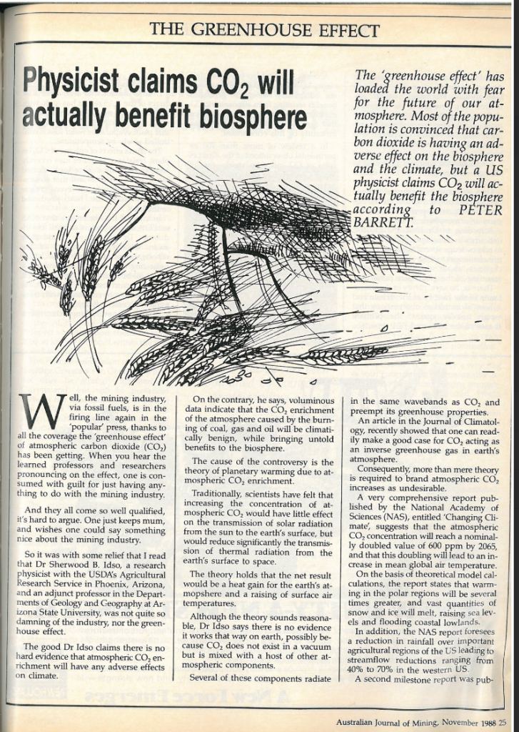

The following year a “think tank”, the Tasman Institute, was created to help push back against environmental and climate policy developments by the Federal Labor government was created..

The Tasman Institute had two major tactics. The first was the production of reports to exaggerate the costs of any proposed action (especially a carbon tax). These were produced to coincide with policy decision choke points or in response to efforts of ‘green’ groups to push for sane climate policy.
The second was to hold seminars and speaking tours, often with invited American scientists, many of whom were deeply embedded in the growing American network of climate delay and denial. (In this latter tactic they were joined by the Institute of Public Affairs – in 1990 it had sponsored the visit of Fred Singer)

Alongside this, Tasman and the IPA would also generate letters to newspapers casting doubt on the reality of the climate science, especially at times when the policy discussions were “hot.” (see for example here and here)

Tasman folded in 1997 – with John Howard in the Lodge it was simply surplus to requirements. In 1997 the “Countdown to Kyoto” conference was held in Canberra. A who’s who of 1990s denial attended.

In November 1996 a strategy meeting was held at the CEI in Washington that would begin to cement the cross-pollination of people and ideas between Australia and the US.110 At the meeting, RJ Smith from the CEI argued that it was clear that “Australia if possible would be a key player in this,” so the CEI decided to hold a conference.111
The CEI112 is a Libertarian anti-regulation “free market” think tank based in the USA. For many years it has attacked global warming science and received more than $2 million in funding from Exxon since 1998. The CEI coordinates the “Cooler Heads Coalition” and the website http://www.globalwarming.org. It is perhaps
best known for its bizarre “CO2 is life” advertisements113 in 2006. Shortly after these ads, ExxonMobil dropped its funding, under pressure from, among others, the UK Royal Society.114
Interviewed by Bob Burton in 1997 Smith said: “Early last winter, right after Tim Wirth of the US State Department announced they were going to call for mandatory controls in Kyoto, we said what do we do? How do we stop this?”115 The CEI’s RJ Smith met Ray Evans of Australia’s Western Mining Corporation (WMC), and the two began planning.
They held a conference in Washington in 1997, and several key deniers were in attendance, along with the Australians. According to PR Watch it “offered blanket dismissals of the scientific evidence for climate change and predicted staggering economic costs for any policies aimed at restricting emissions116.”
Australian Embassy Chief of Mission Paul O’Sullivan, gave the address.
In August 1997, the CEI and the anti-regulatory organization, Frontiers of Freedom sponsored another Australian conference, this time in Canberra, along with the Australian and New Zealand Chambers of Commerce and the WMC. Ray Evans and WMC’s Managing Director Hugh Morgan played a significant role at the conference, and attendees included the Australian Deputy Prime Minister Tim Fischer and Environment Minister Robert Hill. Fisher claimed that tough emission reduction targets could put 90,000 jobs at risk in Australia and cost more than $150 million.117
Speakers included American climate denier Patrick Michaels, climate denier politicians, Rep. John Dingell118, then Senator Chuck Hagel and Richard Lawson (President and Chief Executive Officer of the US National Mining Association and present at the earlier CEI meeting).
According to RJ Smith from the CEI, the purpose of the Canberra conference was to “try and buck [Prime Minister John Howard] up a little more and let him know that there is support of the American people” for his government’s obstructionist stance.119 Later that year, an Australian at the CEI, Hugh Morley, noted on the CEI’s website that “If Australia sticks to its gun (sic), there might not be a Kyoto treaty after all.”120

Source – Greenpeace US 2013 Dealing in Denial

However, denialism still wanted an Australian home, and it found it in the “Lavoisier Group” (Hodder, 2009)

In 2005 the IPA created the “Australian Environment Foundation” deliberately named to create confusion with the ACF - this sort of “innocuous” title, designed to create confusion and complacency, had a venerable history.

Various other groups sprang up, especially during the “carbon tax wars” of 2007-2012. One was an offshoot of the AEF - Australian Climate Science Coalition - DeSmog American groups like the Heartland Institute held some conferences here. The history of the global network of thinktanks dedicated to justifying a host of billionaire desiderata - including but also far beyond climate denial/delay - is covered by Jeremy Walker, who I believe is also making a submission.

The “denialist” lobby and its favoured tactics

Favoured tactics
- Economic modelling, often ahead of key policy chokepoints etc (then funnelled to willing journalists and columnists. Bonus points if this can be “laundered” via a parliamentarian, and then given an extra halo of credibility.
- The “book” - from John Daly’s “The Greenhouse Trap” (1989) onwards to Ian Plimer’s 2009 “Heaven and Earth” and onwards.
- The “tour” - by some figure - academic, scientist, politician. The apogee (or nadir) of this is the 2009 visit of Christopher Moncton,during the Gillard Government’s successful attempt to shepherd an ETS through Parliament. Monckton provided lots of cheap copy for the Murdoch media, but somewhat blotted his copybook by calling Ross Garnaut a Nazi.
- The creation of astroturf groups (see the recent work of journalist Michael Thomas about this in the United States versus renewable energy in a podcast).
- Social media blitzes, since nobody reads books anymore.

These tactics (and others) fit within a broader strategy of
- Supporting the status quo, and rendering it as “normal” and “good” at best and too expensive/risky to do anything about at worst (“better the devil you know”). The disinformation and misinformation efforts are designed to stiffen the spine and offer talking points to those opposed to clean energy/progressive policies etc.
- Delegitimising individuals and groups who have any significant qualms about the status quo, in an effort to demoralise them and get them to self-censor (induced spiral of silence) (“not real Australians” “out of touch inner-city latte-sipping elitists” “grant-grubbing rent-seeking scientists” etc) see “Terrain denial” - Irwin, R., Bowden, V., Nyberg, D., & Wright, C. (2021). Making green extreme: defending fossil fuel hegemony through citizen exclusion. Citizenship Studies, 26(1), 73–89. https://doi.org/10.1080/13621025.2021.2011145
- Delegitimising actions (be they policies, technologies, behaviour changes) that would reduce present or future demand for high-energy/fossil-fuel intensive products (energy, meat etc)
- Maintaining the uncertainty/helplessness/disengagement and feelings of futility and powerlessness among those who are simply trying to survive in times where the Australian Settlement is a very distant memory indeed.

Forms of climate denial

In their 2022 book “The rise of ecofascism” Sam Moore and Alex Roberts outline five kinds of denial

- Trend
- Attribution
- Impact
- Action
- Urgency

(See also Walker, and Leviston, 2019: There are three types of climate change denier, and most of us are at least one. The Conversation).

Different tactics supporting these five types of denial will be used, depending on the intent of the disinformer and their target audience. A deeper typology of this would be interesting, and perhaps useful, but is beyond the scope of this submission.

Disinformation and Misinformation tactics used

An extremely useful typology of climate denial is provided by Lamb et al (2020)

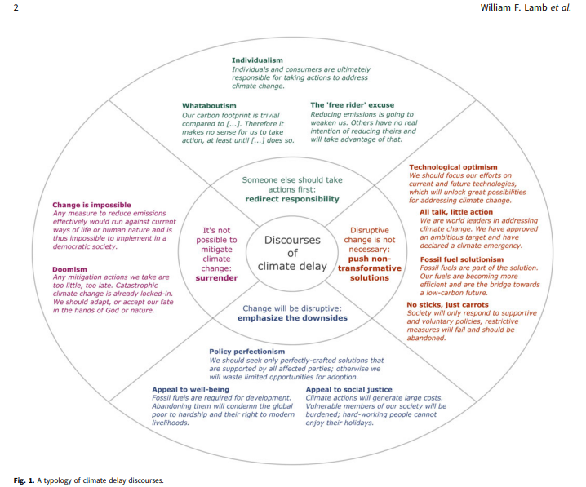

Trend - The most sophisticated approaches no longer deny warming, but ascribe it to “natural cycles”

Action - Ascribe all blackouts to renewables being unreliable or swamping the grid with intermittent supply. On this tactic, in South Australia 2016, see Lucas 2017 and for Spain 2025 see Joshi 2025

Appeals to masculinity, power, patriotism(see “petro-masculinity”)

“Teaching the debate” - blind people with “science”

“Shoot the messengers” - discourage people from participating (attack the scientists)

Smear the existing technologies and exaggerate (or create from nothing) “problems” such as “wind turbine syndrome”

Useful academic and non-academic concepts (in alphabetical order)

Anti-reflexivity
The opposition to thinking about how the technologies that have brought prosperity have also brought problems.

Here’s a short video that does a reasonable (MRDA) job of explaining it

Video: Dwight Towers, ‘Anti-reflexivity for Beginners’ — Theory, Culture & Society | Global Public Life

McCright, A. M., & Dunlap, R. E. (2010). Anti-reflexivity and climate change skepticism in the US general public Theory, culture & society, 27(2-3), 100-133.
McCright, A. M. (2016). Anti-reflexivity and climate change skepticism in the US general public. Human Ecology Review, 22(2), 77-107.

Recent Australian research -
Fraser, B. Sharman, R and Nunn. P. 2023. Associations of locus of control, information processing style and anti-reflexivity with climate change scepticism in an Australian sample. Public Understanding of Science . 2023 Apr;32(3):322-339. doi: 10.1177/09636625221116502

“Impact Science” versus “Production Science”
So many of the debates about climate change and technology become bogged down/useless because the word “science” gets thrown around without thought (by opponents and proponents of action). A useful distinction to use is that of Alan Schnaiberg

Production science
nuclear, genetic modification etc.

Impact science
measures the impacts (obvs) of the roll out of production science. Markedly less popular with the rich and powerful than production science, for obvious reasons.

Kayfabe
In professional wrestling, the “pretend” that those paid actors are not in fact acting. The audience knows it is a lie, but enjoys the show, so everyone goes along with it.
As per that song “The sun in your eyes. Made some of the lies worth believing”

Petro-masculinity
Here is the abstract to Daggett (2018)
“As the planet warms, new authoritarian movements in the West are embracing a toxic combination of climate denial, racism and misogyny. Rather than consider these resentments separately, this article interrogates their relationship through the concept of petro-masculinity, which appreciates the historic role of fossil fuel systems in buttressing white patriarchal rule. Petro-masculinity is helpful to understanding how the anxieties aroused by the Anthropocene can augment desires for authoritarianism. The concept of petro-masculinity suggests that fossil fuels mean more than profit; fossil fuels also contribute to making identities, which poses risks for post-carbon energy politics. Moreover, through a psycho-political reading of authoritarianism, I show how fossil fuel use can function as a violent compensatory practice in reaction to gender and climate trouble.”

Further reading on petromasculinity
Barla, Josef, and Sophie Bjork-James. "Introduction: Entanglements of anti-feminism and anti-environmentalism in the far-right." Australian Feminist Studies 36.110 (2021): 377-387.
Brayshaw, M. (2025). Resourceful melodrama: carbon capitalism and the fossil unconscious in Dymphna Cusack’s Southern Steel (1953). Textual Practice, 39(3), 407-425. DOI: 10.1080/0950236X.2024.2380591
Breunig, M., & Russell, C. (2020). Long-term impacts of two secondary school environmental studies programs on environmental behaviour: The shadows of patriarchy and neoliberalism. Environmental Education Research. https://doi.org/10.1080/13504622.2020.1749236
Daggett, C. (2018). Petro-masculinity: Fossil fuels and authoritarian desire. Millennium, 47(1), 25-44.
Letourneau, A., & Davidson, D. (2022). Tracing Resistance: Hypermasculinity and Climate Change Denial in the Heart of Alberta's Oil Country. In Gender and the social dimensions of climate change (pp. 89-108). Routledge.
Lewis, P. (2024). Re-attaching to coal in a Climate Emergency: The case of the Whitehaven mine. Environment and Planning E: Nature and Space, 7(4), 1821-1843.
Manhire, R. (2024). Love Thy Enemy?: Understanding and Responding to the Self-Destructive Necro-Politics of Petro-Masculine Climate Refusal. Sukupuolentutkimus-Genusforskning, 37(4), 27-43.
Nwokolo, S. C.2025 Climate hoax: The shift from scientific discourse to speculative rhetoric in climate change conversation Next Research.Volume 2, Issue 2, https://doi.org/10.1016/j.nexres.2025.100322.
Perry S (2024) ‘The Australian way’: the gendered and racial logics of Scott Morrison’s climate change narratives, Australian Journal of Political Science, 59:1, 20-36, DOI: 10.1080/10361146.2023.228359
Redshaw, S., & Condie, J. (2025). Techno-capitalist colonialism powered by combustion masculinity in the transition to electric utility vehicles: an analysis of Australian car advertising. Continuum, 1–16. https://doi.org/10.1080/10304312.2025.2545524
Schmelzer M. and Büttner, M (2024) Fossil mentalities: How fossil fuels have shaped social imaginaries. Geoforum, Volume 150, https://doi.org/10.1016/j.geoforum.2024.103981.
Verlie, B. 2024. Feeling climate injustice: Affective climate violence, greenhouse gaslighting and the whiteness of climate anxiety EPE: Nature and Space 2024, Vol. 7(4) 1601–161 DOI: 10.1177/25148486241252734

Reflexive Modernisation
Here’s a video - Reflexive Modernisation in 100 secs

See also Anti-reflexivity

Settler colonialism
van Holstein, E., & Head, L. (2018). Shifting settler-colonial discourses of environmentalism: Representations of indigeneity and migration in Australian conservation. Geoforum, 94, 41-52.

Spiral of Silence
Heald, S. (2017). Climate silence, moral disengagement, and self-efficacy: How Albert Bandura's theories inform our climate-change predicament. Environment: Science and Policy for Sustainable Development, 59(6), 4-15.

Recommendations

Here is a roughly prioritised list

Expect the denialist lobby to (attempt to) innovate
Just because they are wrong does not mean they are stupid or lazy. The fossil fuel interests and the rich generally who pretend to like free markets (they actually want socialism for the rich) are able to hire good “creatives”. They have been very very effective for decades. While their task gets harder as the seas rise and living conditions plummet, don’t wait around for them to give up or fail easily, because they won’t.

Have compassion
Especially for those who are passing these things on. (less for the generators of them, obviously).
Be aware of the difficulties that nominal social democratic parties have in coping with limits to growth

Move beyond top down models
The last two items of the Terms of Reference are revealing and worrying. The problem is not (just) that the government and state has largely failed over the last 4 decades to respond to the climate crisis, but that civil society (of which social movements are only subset) have been unable to grapple - in a serious, non-cooptable and irrepressible way, with the thorny issues.

Reconfiguring Relationships: Social Innovation, Action Research, and Transformation - Koen P.R. Bartels, Julia M. Wittmayer, Andrea Rodericks, Hilary Bradbury, 2025

Name names
"The earth is not dying, it is being killed, and those who are killing it have names and addresses." Utah Philips

Name the international links
Especially but not just the US ones

Name tactics (and counteract them appropriately)
See above section

For Gaia’s sake don’t bring a “science” knife to a culture gunfight.
We have tried endlessly presenting the science. It doesn’t on its own resonate. Have better metaphors for the science - I personally like (and overuse) the “you’re lying in bed” metaphor.

“You’re lying in bed on a Sunday morning. Not too warm, not too cold – like the porridge that Goldilocks steals – just right. Your mum comes in and says “get up you lazy so-and-so” and pulls off the duvet. Instantly you are too cold. Or – sliding doors – your mum comes in and says “oh, darling, have another duvet” and throws one on. For a moment the extra warmth is nice, but pretty quickly you overheat.
“Well, the Sun is 6 and a half light minutes from earth. If all the heat that hits the Earth bounced off it would be 18 degrees below zero. But there is a duvet of gases – carbon dioxide, water vapour, some others – that trap a certain amount of the heat. Over the last two hundred plus years, we have been making that duvet thicker. Every time we burn oil, coal and gas, to get electricity, make heat, whatever, carbon dioxide is released. Some of it gets pulled out of the air by trees or the oceans, but more of it stays there. The Keeling Curve (points to tattoo) measures how thick the duvet is. So all the stuff you hear about renewables this, nuclear that, whatever – the key thing to ask is “is this making the duvet thinner, or is it even slowing down the rate that the duvet is getting thicker?” And the answer is no. (source)

Expose the logical fallacies (but with humour and “zingers”)
Do this wrong and you come across as a pointy-headed latte-sipping elitist. If you can’t do it with humour and concision, you are probably making the situation worse rather than better.

Specifically on the “but science” conflation
Distinguish between impact science and production science
Talk about the Treadmill of Production and Consumption.

Explain the underlying drives - both economic and ideological/cultural (the two are entwined) underneath
This is tricky - you can end up sounding like the love-child of Sigmund Freud and Al Gore, and nobody wants that.

Use humour, where appropriate
There is a great deal of brilliant cartooning (David Pope, First Dog on the Moon etc etc etc.) Obviously this is an incredibly serious issue (the most serious one ever) but humour helps people relax and relate to you.

Be aware of the Gish Gallop problem (and name it)
An opponent of action can throw out a long list of insinuations and half-truths, quarter truths and outright fabrications. Rebutting each of these takes time and audience bandwidth which is then not available for putting forward the case for action.

Be aware of the global context
Put disinformation/misinformation campaigns in Australia in global context. This is not to say there are no special features (settler colonialism) nor that the most sophisticated campaigns will draw upon specific Australian ‘memes, nor that all those repeating (or even generating) disinfo and misinfo are paid dupes of some global conspiracy

References and some suggested further reading.

Guenther, G. 2024. The Language of Climate Politics: Fossil-Fuel Propaganda and How to Fight It. Oxford University Press

Hodder, P. 2009. Lobby groups and front groups: industry tactics in the climate change debate. Melbourne Journal of Politics (Vol. 34)

Hudson, M. 2017. Wind beneath their contempt. Energy Research & Social Science,
Volume 28, Pages 11-16,
https://doi.org/10.1016/j.erss.2017.03.014.

Hudson, M. 2017. Who tilts at windmills? Explaining hostility to renewables The Conversation

Kurmelovs, R. 2024. Slick: Australia’s Toxic Relationship with Big Oil. University of Queensland Press.

Lamb WF, Mattioli G, Levi S, et al. Discourses of climate delay. Global Sustainability. 2020;3:e17. doi:10.1017/sus.2020.13

Lucas, A. (2017). Confected conflict in the wake of the South Australian blackout: Diversionary strategies and policy failure in Australia's energy sector. Energy research & social science, 29, 149-159.

Joshi, K. 2025. Why no one is asking questions about Spain’s mysterious missing nukes

Moore, S. and Roberts A. 2022. The Rise of EcoFascism: Climate Change and the Far Right. Polity.

Tangney, P. (2019). Between conflation and denial–the politics of climate expertise in Australia. Australian Journal of Political Science, 54(1), 131-149.

Wright, C and Nyberg, D. 2021. Beyond the discourse of denial: The reproduction of fossil fuel hegemony in Australia - ScienceDirect

