“We’re gonna need
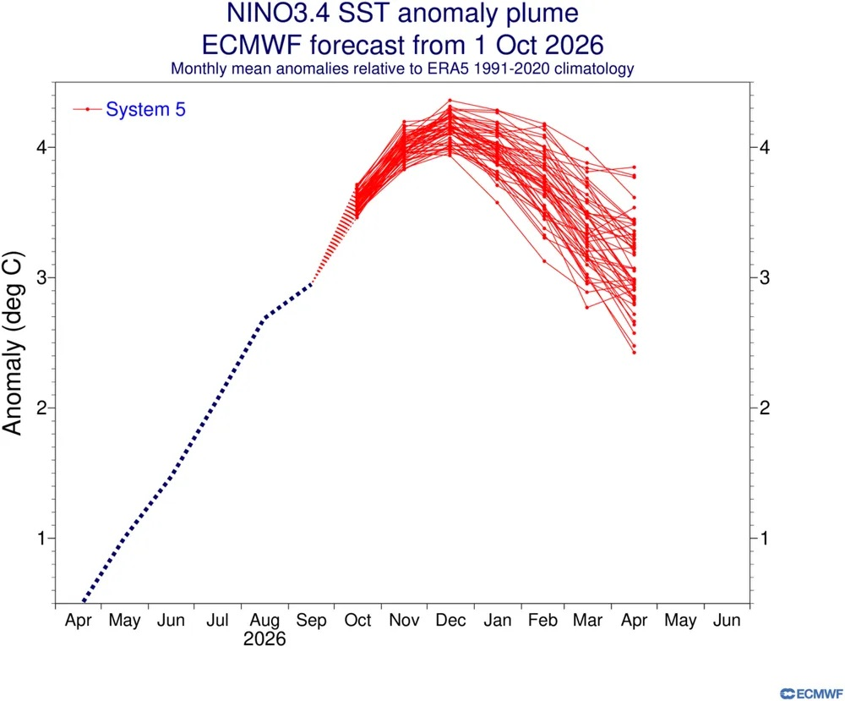
What the image is all about
SST = Sea Surface Temperatures. How high might they go in the mid-Pacific by some point in December?
ECMWF = European Centre for Medium-Range Weather Forecasts.
See editorial (page 2) for more on this.

a bigger y-axis…”

Joke of the Week
With all this talk Doom and Gloom, a reader could get mildly anxious. Therefore, there’s a new section - the joke of the week. Given the various oscillations (ENSO, PDO, AMO, NAO) let’s go with this…
How do you titillate an ocelot?
Answer on the last page of this issue…
Welcome to the fourth of many (several?) weekly issues of the El Niño Digest Times (END Times - geddit?). The why should be self-explanatory, but here’s a FAQ just in case. We are still just about in the first of the three phases of El Niño but not for long… (see this page for that)

Here’s the database I’ve begun (but almost certainly will not maintain). It’s largely based on two Google Alerts for “El Niño” and “Impacts” and “Godzilla”. Plus things people (like you) send me.

There are a lot of good El Niño explainers out there - this one, by Al Jazeera is really good and I will link to it at the top of every digest until someone suggests a better one (ideally with the url written on a £50 note).

Editorial -The numbers racket?

How high can we go seems to be the question on a few people’s minds. Personally, it reminds me of the debates in the early 1980s (yes, I am that old) about both the Americans and the Soviet Union having enough nukes to blow up the world however many times over. We didn’t have that Simpsons meme “stop, he’s already dead?” back then, but the sentiment existed all the same.

I remember, more recently, someone thinking that once we breached 400ppm of atmospheric carbon dioxide, then this would Mean Something, and our glorious leaders would be under more pressure to Do Something. Well, that day came and went and outside the geeks and weirdos (and people with Keeling Curve tattoos on their forearm) it all amounted to a “nothing burger” as our valiant defenders of freedom in the Republican Party used to be fond of sneering.

But numbers, I guess, give you a sense of knowledge, which in turn gives you a sense of control. That it is all an illusion is neither here nor there - we all need our illusions, after all.

So, - as per the nice image on the front page - at some point in December (or January? Who knows for sure anymore) , the Sea Surface Temperatures in that particular part of the Pacific the boffins call 3.4 will peak, perhaps plateau or dip, perhaps rise again like a zombie that hasn’t been head-shot. But it will then steadily start to come down And many electrons will give their lives* to generate pixels to tell a few people what is happening there. Meanwhile, millions of humans and other species will be trying to cope with droughts, floods, storms,”etc” as the Great Unravelling, the Fafocene, gets that much nearer.

Fun times.

(*) Yes, I know that’s not how either sub-atomic particles or computers work. It’s late, I’m trying to wax poetic.

The three phases of El Niño

- The Antici…pation
From early this year until … (looks at watch)... about now. Scientists saying they’ve double-checked and triple-checked and they’re as sure as they can be. Disaster management folks pleading for money and decent plans. Politicians telling us to stock up, or declaring States of Emergency in advance, with an eye on their 2028 Presidential run… Journalists writing SEO-ed disaster porn speculations. Everyone holding their breath, putting their fingers in their ears to not hear the Doomers gloating “I told you so.”
- “Then someone yelled out ‘Contact!’”
The rolling roiling disasters, especially salient when (rich) White People in Peril can be filmed. The shark in the shopping mall meme resurfaces. The re-insurers point to their fine print, and some insurers go belly-up. The rich libertarians squeal for state bail-outs. Food prices through the roof. Hard-to-replace infrastructure washed away.
- Back to the perfect paradise
The wreckage is quietly swept away, the global machine reboots, and the important (rich white) people continue their merry way. The End. (Actual outcomes may vary; always read the label).

Excerpts from Recent Reports

Physical impacts
To paraphrase Aristotle “Anybody can become terrified— that is easy, but to be terrified about the right horrorshow and to the right degree and at the right time and for the right purpose, and in the right way — that is not within everybody's power and is not easy.”

Earth
“By seven in the morning, the heat is already settling over the fields of Siem Reap province, Cambodia. The air is still, the land is dry, and the rice is dying. There is no smell of wet earth, no sign of rain.
"I have never experienced a drought this long in my life," says Sokhoeun Chhut, a 45-year-old farmer in the province. "This year is definitely a loss. It’s all scorched. It’s hot as fire."
Anon, 2026. When El Niño brings drought, every minute counts. FAO Newsroom, October 5

Water
“On the shores of Playa del Rey sits L.A.’s last line of defense against sewage streaming into the Santa Monica Bay — and a jacked El Niño this winter threatens to be more than a match for it.
Built in 1950, the Hyperion Water Reclamation Plant handles roughly 95% of the city’s sewage on any given day — up to 800 million gallons of effluent from toilets, washing machines, sinks, industrial operations and more.
Storms can overwhelm the aging facility, which suffered an equipment breakdown in 2021 that led to a massive amount of raw sewage gushing into the Santa Monica Bay. Los Angeles officials are bracing for more trouble if the forecasted “super” El Niño brings heavy rains and flooding…”
McDonald, S. 2026. ‘Super’ El Niño could overwhelm L.A.’s aging Hyperion sewage treatment plant. LA TImes, October 2

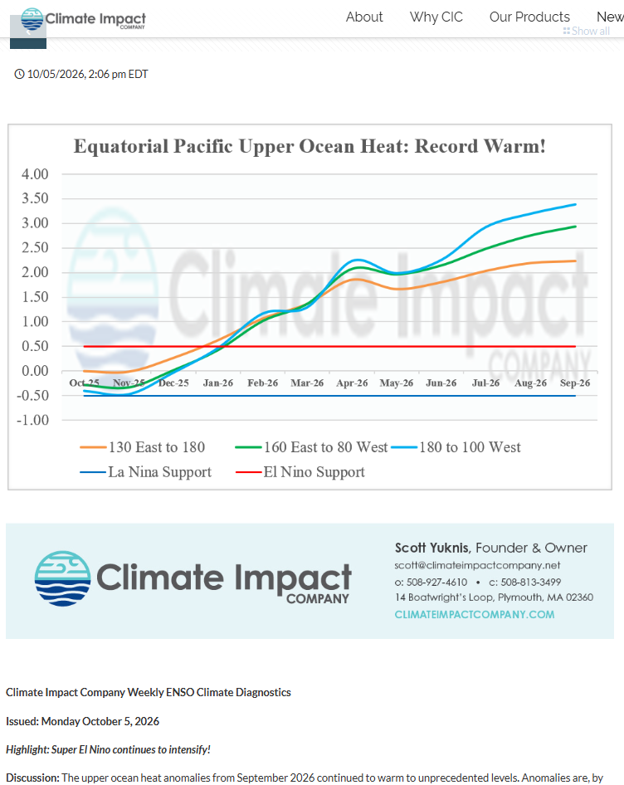
https://climateimpactcompany.com/weekly-enso-diagnostics-super-el-nino-continues-to-intensify-3/
https://climateimpactcompany.com/weekly-enso-diagnostics-super-el-nino-continues-to-intensify-3/

Money
(always the fifth element, whatever Aristotle had to say)
“A normal supercycle is an extended period of time where the price of a broad range of commodities, such as metals, energy, and food, all increase due to growing demand.
“These years-long periods are usually set off by the build-out of new infrastructure and manufacturing capacity, a surge in industrialization, and are underpinned by a rising cost of energy.
“The climate supercycle is different. This supercycle won’t be driven by global economic growth, but by the coupled costs of climate impacts and the effort to build out an economy that means we reduce carbon emissions.
“The supply constraints imposed by climate impacts will offset the growth generated by investments in renewables and electrification, creating a stagnant global economy increasingly crippled by persistently high inflation - call it climate stagflation.
We can break down the costs. Major financial analysts such as Goldman Sachs and HSBC estimate that this El Niño could push global food commodity prices up by 15 per cent or more.
Beuret, N. 2026. Godzilla El Nino is coming. The Ecologist, October 5

56 minutes of solid “briefing for capitalists”
In this session, Marsh experts explored how El Niño is affecting weather patterns, trade routes, commodity flows, logistics planning, and wider supply chain resilience. The discussion looked at what is changing across sectors, where impacts are already being felt, and what businesses should consider as they plan for the months ahead.
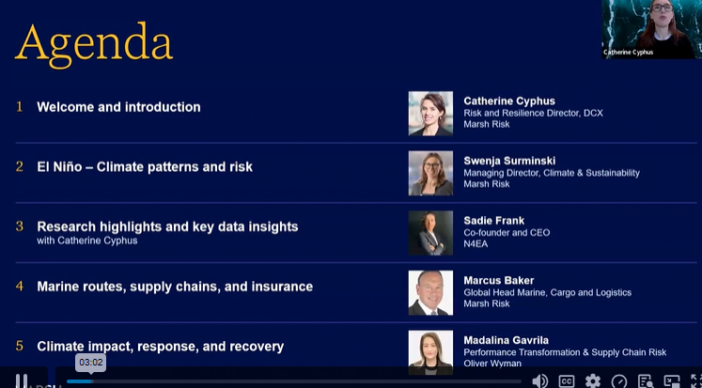

El Niño can create fast-moving and far-reaching disruption across global supply chains.
Impacts vary by sector and geography, but transportation, energy, agriculture, and marine routes are especially exposed.
Early visibility into supply chain risk can help businesses improve resilience and recovery planning.

Global supply chains under pressure: The impact of El Niño| Marsh

India
Between June and September, India received its lowest rainfall in more than a decade owing to the El Niño effect.
India’s foreign minister has warned El Niño, coupled with fertilizer shortages due to wars, will lead to a major food crisis in the coming months.
El Niño is expected to materially slow down India’s rural economy and lead to a sharp rise in inflation.
Rural demand in India is key for major multinational companies such as HUL, Colgate-Palmolive, Nestle, and the automaker Maruti Suzuki.
Salve, P. 2026. Inside India newsletter: Food crisis, economic shock ahead as India braces for El Niño. Inside India, October 7

Sri Lanka
“Sri Lanka has been mired in drought for months, leading to severe water shortages that have left reservoirs dry and strained farming communities that depend on seasonal monsoons. Making matters worse, temperatures in many parts of the country have been higher than usual and high humidity has exacerbated the heat stress.
“We feel like we are being hit from every side,” Pushpakumara said. “If there is no water and we have to give up farming, we will have nothing left to live on.”
ERANGA JAYAWARDENA and SIBI ARASU (2026) In drought-stricken Sri Lanka, farmers watch wells empty and wildlife crowd shrinking water hole. Associated Press,, October 8.

FCO issues travel advice for: Peru, Ecuador, Japan, India and California
UK Foreign Office issues Godzilla El Niño travel warning for Londoners heading to these countries | The Standard
Check your travel insurance policies, eh everyone?

Chile
SANTIAGO, Chile (AP) — Heavy rains drenched Chile’s capital and the surrounding region Thursday, triggering mudslides that swept cars through streets, flooded homes, forced residents to evacuate and injured at least six people, authorities said.
AP, 2026, Heavy rain batters Chile’s capital, sweeping away cars and flooding homes. October 9.

Australia
“Albo Takes Break From Approving Fossil Fuel Projects To Tell Pacific Nations About El Nino”
From The Shovel
Prime Minister Anthony Albanese has told staff he won’t be able to approve any coal and gas projects for the next 48 hours while he travels to a summit in Fiji to lecture Pacific nations on the effects of climate change.
Swapping his favourite Woodside polo for a colourful Fijian shirt, Albanese – whose government has approved 37 new or expanded fossil fuel projects since taking office – told the summit that “climate change is not a problem for the future. It is here right now”.
“It was a moving speech,” one local said. “At one point he did accidentally switch to a different speech which confirmed that BHP will be able to extract a further 55 million tonnes of coal at its Saraji mine. But that’s understandable – he’s a busy guy, there’s a lot on his plate”.
The Prime Minister then spent the afternoon at a series of bilateral meetings, in which he expressed deep concern about the Pacific’s future and a firm commitment to being photographed looking concerned about the Pacific’s future.

Two emission paths diverged in a yellow wood…
The real danger is steadily escalating planetary heat. The only way forward is to end billionaires.
“It feels like the world is currently kind of letting China crank out solar panels, but otherwise descending into a sort of paralyzed, corporate-fascist madness.
“We surely ought to be going much faster. We ought to do everything we can, collectively, as a species of animal in a biosphere on a planet, to stop killing that planet. It’s gone much too far already. The faster we slow - and eventually stop - global heating, the more lives, species, and life-support capacity we will save. That will stay true for the rest of our lives….
It wasn’t rocket science: educate the public, tamp down disinformation, ramp up solar and batteries, ramp down fossil fuels, make sure the initial costs are distributed progressively. After some initial period, the costs to society turn into benefits, into cost reductions and competitive advantages. An average seventh grader could have done far better than our governments. Why, then, didn’t our governments do these obvious things? Because they didn’t want to do them. Why not? Because they’re corrupted by the billionaire class. Increasingly, they are the billionaire class. And the billionaire class exists because of enclosure and extraction. Fossil fuels are the perfect energy source for powering class inequality….
Kalmus, P. 2026. We’re In Deep Shit, But Not Because of El Niño

Well, this isn’t good…
“During the 2023–2024 El Niño, about 75% of the world's tropical forest areas experienced at least six months of unprecedented simultaneous drought and heat. According to a study published in Earth's Future, this scenario offers more than just a snapshot of an extreme event; it offers a preview of the "new normal" for the next two decades if greenhouse gas emissions are not reduced.”
Extreme drought and heat from the last El Niño signal a 'new normal' for tropical forests
The 2023–2024 El Niño as a Preview of Future Tropical Forest Climate, Earth's Future (2026). DOI: 10.1029/2026EF008071

Songs for the times
- “You ain’t seen nuttin yet” by Bachman Turner Overdrive
- “Who’ll Stop the Rain” by Creedence Clearwater Revival
- “Stormy Weather” by Lena Horne
- “Let’s face the music and dance” by Nat King Cole
- “It’s only four degrees” Anohni
- “The tide is high” Blondie
- “Blue Sky Mine” by Midnight Oil
- “The Next Storm” by Frank Turner
- “Riders on the Storm” by The Doors
- “Under Pressure” (Queen/Bowie)

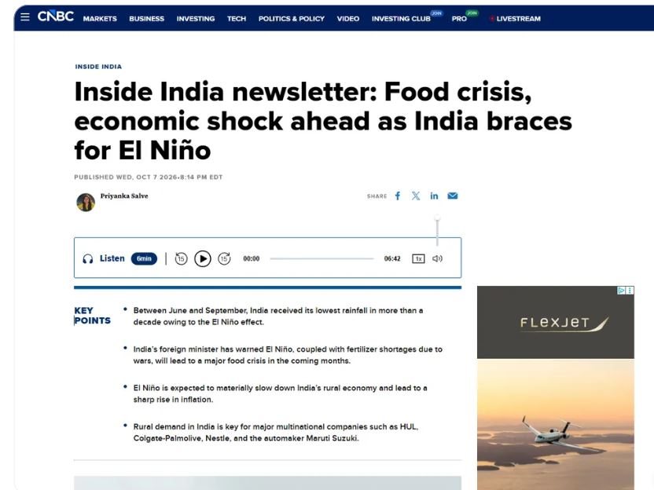
Face-palm of the Week
Highly appropriate advert, eh?
https://www.cnbc.com/2026/10/08/el-nino-food-economy-crisis-india.html
When will it all end?
“This year's El Niño will intensify before peaking in December and is nearly 100% certain to last until February ​2027, the World Meteorological Organization said in its monthly climate bulletin ‌on Thursday, with sea surface temperatures set to break records.
“WMO forecasts indicate a near-100% likelihood that (El Niño) will persist through February 2027, potentially being one ​of the strongest since at least 1950," WMO Secretary General ​Celeste Saulo said in a statement released with the bulletin.”
Anon, 2026. UN weather body says El Niño set to intensify and last until February 2027. Reuters, October 8.
How will it all end?
“We can’t predict with any certainty how this event will end, says McPhaden. The 1997 El Niño ended with a bang, with sea-surface temperatures in the eastern equatorial Pacific plummeting by 8°C in a month, followed by a strong, long-lasting La Niña. But the next strong El Niño in 2015 faded gradually and was followed by a weak, short La Niña.”
Le Page, M. 2026. The world may never go back to how it was after this monster El Niño. New Scientist, October 8

But will it? Because, see the bowel-looseners…
Bowel-looseners of the week
PP: What kind of climate regime shift do you fear most?
J-S K: I am particularly concerned about the persistent shift in major ecosystems, such as the Amazon rainforest moving toward a much drier and degraded state. You know, a long time ago the Amazon was a savannah area, so we are now approaching this kind of tipping point. Also, in the Amazon, this drying can weaken [or] even reverse the forest's role as a carbon sink.
The Amazon is a carbon sink, but imagine it becomes drier and drier, and there's some die-back of the forest. Now, [carbon] sink becomes source. This could amplify global warming long after an El Niño event
Pester, P. Super El Niño may push an already stressed climate ecosystem across a critical threshold, climate change researcher says. LiveScience, August 4

“I expect that this super El Niño event will drive multiple climate regime shifts like we’ve seen after past super El Niño events,” says hurricane specialist Jeff Masters. “Regime shifts tend to cause considerable trouble – significant disruptions to ecosystems and to the humans that depend on them…. Our civilisation is adapted to the climate of the 20th century, and it is costly and disruptive to be forced to deal with sudden climate regime shifts,”

Le Page, M. 2026. The world may never go back to how it was after this monster El Niño. New Scientist, October 8

Stuff to watch for in the next week

Monday 12th October - National Emergency Briefing on El Nino (currently at capacity - 10k people have registered on Zoom!

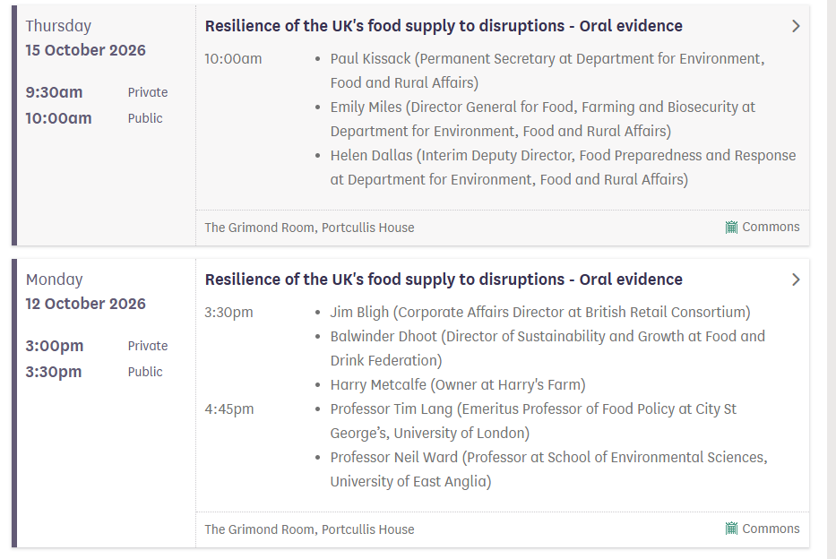
Also though, the Public Accounts Committee is looking at Resilience of the UK's food supply to disruptions - Committees - UK Parliament On Monday 12th and Thursday 15th. These oral evidence sessions are live streamed. Grab your popcorn (while there still is, er, popcorn

Help!!!
Is anyone interested in helping collate, layout and proof-read this digest?
I am almost certainly going to stop doing it at the end of October - it’s too much of a timesuck to do solo. Any takers? Get in touch via @allouryesterdays.bsky.social
Quotes of the Week
"El Niño is like loading the dice. While we're loading the dice for a certain type of response from El Niño, we still know that in any given year, there are still natural fluctuations that may mask that or cause the response to be slightly different than what we might expect."
Daniel Vimont, professor of atmospheric and oceanic sciences at the University of Wisconsin-Madison quoted in Sommer, L. 2026. Super El Niño is here. What's so super about it? NPR, October 5

“Recently, I watched the awarding ceremony of the 59th Search for the Ten Outstanding Students of the Philippines (TOSP) Region 3, where P&A Grant Thornton was honored to be among the sponsors. The guest of honor was Dr. DJ Darwin Bandoy, a TOSP alumnus and the Director of Research and Creative Work at the University of the Philippines Resilience Institute, home of Project NOAH.
“His message was direct, urgent, and unsettling.
"It's time to press the panic button."
“… According to Dr. Bandoy, we are only at the beginning of the story. While El Niño may peak toward the end of 2026, some of its harshest impacts may be felt during the first quarter of 2027, when rainfall becomes even rare and water shortages intensify. This observation is consistent with PAGASA projections showing that the most critical drought conditions could emerge between January and March 2027. “
Maute, Y. 2026. It's time to press the panic button on “Godzilla" El Niño. Grant Thornton October 7

The WMO’s Secretary-General, Celeste Saulo, said: “El Niño doesn’t add new heat to the planet. It releases heat the ocean has already been storing beneath the surface – which is why a strong event so often becomes one of the hottest years measured (as with 2024).
“The ocean it’s drawing from is the warmest we’ve ever measured it. There is simply more heat available to release.” Glover, A. 2026. When Will 2026's El Niño Will Peak And End? | HuffPost October 8

“The warning lights are flashing. ... This extreme El Niño event will have widespread global impacts,” said Daniel Swain, a climate scientist at the University of California, Los Angeles. “We’ve never seen an event this big before in the context of our rapidly warming climate.”
Mahan, K. 2026. Godzilla-level, mammoth, supersized? Whatever the label, this El Niño could surpass even an 1877 titan. Boston Globe, October 8

“We keep writing these urgent reports and nothing ever happens,” [Professor Tim Lang] said. “How many prime ministers have said they will prioritise tackling UK food security and done nothing? I do believe that the food industry’s attitude has changed and they realise that much more has to be done but we need the government to act and more MPs to demand action. Defra has been a weak and politically neglected department. That has to change.”
Quinn, I. 2026. Climate change ‘war room’ set for launch amid food shortage fears. The Grocer, October 6.

Podcasts and Videos
How will ‘Godzilla’ El Niño impact us?
Turkish Public Broadcaster October 5, 22 mins.
Olivia Lazard Senior Fellow at Carnegie Europe
Jonathan Stone Climate and Resilience manager at the International Federation of Red Cross and Red Crescent Societies (IFRC)
Samantha Burgess Deputy Director of the Copernicus Climate Change Service
Jim Dale Senior meteorologist.
Not bad.

Links
For a FAQ see here. The comedy of El Nino (no, really) it’s a 1997 video. El Nino acronyms El Nino quotes
El Nino videos El Nino timeline up to 2025

Disclaimers
I am not a climate scientist. I am mostly collating what other people say, not pushing my own “angle”. I will get things wrong - when I do, I’ll fess up, no fuss. I will quote from “reputable” sources, but sometimes the truth is an outlandish outlier.
Blah blah information provided for lulz only. No responsibility taken for your failure to create broad-based social movements that prevent shit getting even worse and instead leading us into the pit of Sarlac.
The digest is inspired by the awe-inspiring and heart-breaking “CO2 Newsletter published by American geologist William Barbat from 1979 to 1982.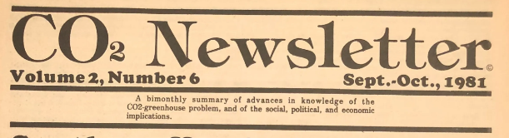


You oscillate its tits a lot.

Don’t @ me.

