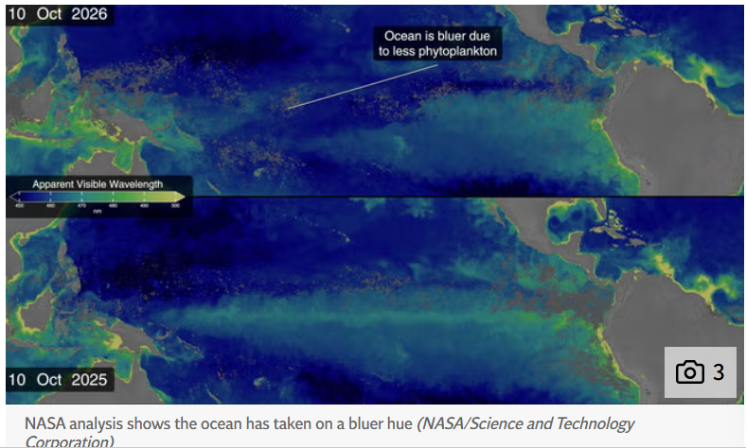
BLUE IS THE

“Earth’s oceans are undergoing a dramatic visual shift, as satellite data reveals that a powerful "Super El Niño" weather pattern is turning green ocean waters a starker, deeper blue.
The visual transformation comes down to phytoplankton – tiny, floating microscopic marine plants that live near the surface of the sea.
Just like trees and plants on land, phytoplankton contain chlorophyll, the green pigment used to turn sunlight into energy. Because of this green pigment, areas packed with floating marine life reflect green light back into space, giving healthy ocean waters a distinct green tint.”
Kidwai, S. 2026.How the ‘Super El Niño’ is changing the colour of the ocean | The Independent October 19
COLOUR

Joke of the Week
A small boy asks his Dad, "Dad, what is ‘politics’?"
Dad says, "Well son, let me try to explain it this way: I'm the breadwinner of the family, so let's call me Capitalism. Your mom, she's the administrator of the money, so we'll call her the Government. We're here to take care of your needs, so we'll call you the People. The nanny, we'll consider her the Working Class. And your baby brother, we'll call him the Future. Now, think about that and see if that makes sense."
So the little boy goes off to bed thinking about what Dad has said. Later that night, he hears his baby brother crying, so he gets up to check on him. He finds that the baby has severely soiled his diaper. The little boy goes to his parents' room and finds his mother sound asleep. Not wanting to wake her, he goes to the nanny's room. (continued page 8!)
Welcome to the 6th and quite possibly final weekly issues of the El Niño Digest Times (END Times - geddit?). The why should be self-explanatory, but here’s a FAQ just in case. We are still just about in the first of the three phases of El Niño but not for long…

Here’s the database I’ve begun (but almost certainly will not maintain). It’s largely based on two Google Alerts for “El Niño” and “Impacts” and “Godzilla”. Plus things people (like you) send me.

There are a lot of good El Niño explainers out there - this one, by Al Jazeera is really good and I will link to it at the top of every digest until someone suggests a better one (ideally with the url written on a £50 note).

Here’s a link to the blog I put up on Wednesday.
Editorial
Last week I promised to riff on “The Jungle Book” (as per “Do you like Kipling? I don’t know, I’ve never kippled”) but that’s tricky since I’ve only read two of the seven stories so far (marking posts about International Relations/Security took up some bandwidth). But tricky does not mean impossible.
In the second story Mowgli (the human boy literally raised by wolves) gets kidnapped by some monkeys and has to be rescued by the bear, the snake and the panther. It’s extremely well-written (just because Kipling had views regarded even then as, ah, ‘out there’, doesn’t mean the man was incapable of writing a ripping yarn. Anyway, the monkeys are a rum lot and this bit leapt out at me.
“Sore, sleepy, and hungry as he was, Mowgli could not help laughing when the Bandar-log began, twenty at a time, to tell him how great and wise and strong and gentle they were, and how foolish he was to wish to leave them. ‘We are great. We are free. We are wonderful. We are the most wonderful people in all the jungle! We all say so, and so it must be true,’ they shouted. ‘Now, as you are a new listener and can carry our words back to the Jungle-People so that they may notice us in future, we will tell you all about our most excellent selves.’
THIS! This my friends is the smugosphere. The self-regard, the certainty, the circularity and inability to seek or accept feedback/innovation etc. El Ninos have been showing us we’re not particularly ready for what’s coming (though there have been regional success stories about adaptation and lessons learned - but there comes a point where your adaptive capacity gets overwhelmed). As I’ve said before, I think what’s gonna happen, regardless of how much physical and economic devastation is caused, is that it will become impossible to believe that some sort of acceptable “normal” can be brought back into existence. This El Niño will show us that we have poked the climate beast with a sharp stick (the image belongs to the late great Wally Broecker) and now it has woken up.
Meanwhile, as Dr Charlie Garner wrote on social media.
“Just 2 days after telling us they're committed to making the crisis worse by greenlighting more fossil fuel extraction, the government is now telling us it's our responsibility to prepare for the impacts of the climate breakdown that's already upon us”
Most but not all of us shall see how well Saint Andy Burnham’s popularity holds up with this sort of “you’re on your own/devil take the hindmost” approach to climate resilience….

The three phases of El Niño
- The Antici…pation
From early this year until … (looks at watch)... about now. Scientists saying they’ve double-checked and triple-checked and they’re as sure as they can be. Disaster management folks pleading for money and decent plans. Politicians telling us to stock up, or declaring States of Emergency in advance, with an eye on their 2028 Presidential run… Journalists writing SEO-ed disaster porn speculations. Everyone holding their breath, putting their fingers in their ears to not hear the Doomers gloating “I told you so.”
- “Then someone yelled out ‘Contact!’”
The rolling roiling disasters, especially salient when (rich) White People in Peril can be filmed. The shark in the shopping mall meme resurfaces. The re-insurers point to their fine print, and some insurers go belly-up. The rich libertarians squeal for state bail-outs. Food prices through the roof. Hard-to-replace infrastructure washed away.
- Back to the perfect paradise
The wreckage is quietly swept away, the global machine reboots, and the important (rich white) people continue their merry way. The End. (Actual outcomes may vary; always read the label).
Quotes of

U.N. Under-Secretary-General for Humanitarian Affairs and Emergency Relief Coordinator Tom Fletcher described the event as a “behemoth” and “a wrecking ball that will likely tear through Latin America, eastern and southern Africa, Asia and the Pacific with extreme heat, droughts and floods.” He warned that around 50 million people could face increased hunger.
Edwards, J. 2026. Map Shows How ‘Wrecking Ball’ El Nino Will Impact Regions Around World. Newsweek, October 22

"We have not seen in ⁠our records 3.8. We have seen around 3 in some record El ​Ninos before, with very substantive impacts across the world. So we are beyond ​that limit," WMO Secretary-General Celeste Saulo said.
El Nino 'wrecking ball' could cause record Pacific temperature rise, UN says | Reuters

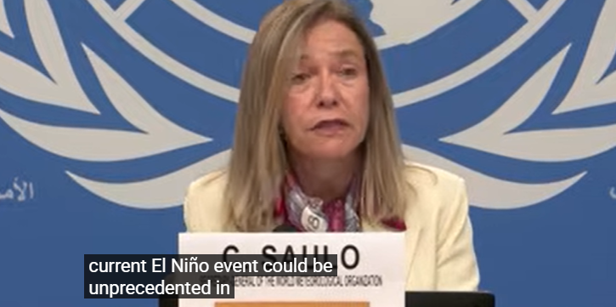

“Marine heatwaves are ripping through our seas like wildfires through a forest, killing sea life and destabilising our weather systems. Just weeks ago, we had a government minister urging Brits to stockpile emergency food and water as the violent and destructive consequences of the climate crisis loom large.
“It is against this backdrop that the Jackdaw gasfield has been approved. The government has undermined UK climate leadership for gas that won’t even lower our bills.”
Helen Honstvet, head of campaigns at Oceana UK,
Hutchins, R. 2026. UK's climate ambition 'in tatters' as Jackdaw gasfield gets go ahead - Oceanographic, October 21

But this year's El Nino layers "a terrifying level of additional risk"..."It is entirely possible that reassessing the status of corals just after this coming El Nino may show them to have crossed

the 50 percent mark of the proportion of species at elevated risk of extinction," s
the week

"When they hit their threshold the collapse of reefs in that region could be precipitous and we don't
know if that is five, 15 or 30 years into the future, or maybe this year with the super El Nino ramping up?"
Marine scientist David Obura chair of IPBES, the UN's expert scientific panel on biodiversity.
AFP, 2026. El Nino a 'terrifying' threat to coral reefs: UN biodiversity expert. France 24, October 15

“We should be clear that this is an unprecedented event… I have not seen an event like this developing in our forecasts before. And assuming the forecasts are correct – and many other centres are giving the same signals – then we’re expecting the biggest El Nino for over a century, peaking at something over 3C. That is unheard of in modern climate records.”
Professor Adam Scaife, head of long-range forecasting at the Met Office, said.
Toth, A. and Whittaker, R. 2026. El Nino tracker: Here’s what the ‘strongest-ever’ weather phenomenon means for UK in 2027 - AOL. October 17

“But I will caution that once El Niño is fully in place and has reached peak intensity, it takes a long time for the atmosphere to disentangle itself from that warm ocean water. And so we do expect the impacts of El Niño to continue at least on through the spring of 2027.”
Brad Rippey, a meteorologist with the U.S. Department of Agriculture
Rook, M. 2026. Record-Breaking El Niño Threatens to Delay Spring 2027 Planting - AgWeb, October 17.

5: The Committee continued to be attentive to other sources of price pressure in the global economy, which could present additional upside risks to UK inflation via import prices. The S&P index for global agricultural and livestock prices had already risen by around 5% since the July Report, and could be pushed higher if harvests were affected adversely by an unusually severe El Niño event. And the continued significant demand for artificial intelligence (AI)-related technology goods and primary products was driving price pressures for affected sectors.
Minutes of the Monetary Policy Committee meeting ending on 16 September 2026
Capitalism will save us!
KUALA LUMPUR: Malaysia's palm oil industry is stepping up efforts to prevent and manage forest fires as a prolonged drought driven by El Nino raises concerns over both crop production and the sector's environmental reputation.
Industry players, led by major plantation companies, have pledged to strengthen joint monitoring and fire prevention efforts, including closer cooperation with local communities and small farm operators to tackle hotspots that contribute to transboundary haze.
Go, M and Ng, S. 2026 Malaysia's palm oil industry steps up fire prevention efforts as 'Godzilla' El Nino fuels haze woes - CNA October 16
"The weather is extraordinary this year. Godzilla El Nino, whatever you call it. Just imagine 100 days without rain. In some areas, 110 or 120 days, not a single drop. You will see some effects very soon because when you get four months with no rain, abortion of fruits is going to come," he added.
Patrick Ng, director of operations at KLK Plantations.
Go, M and Ng, S. 2026 Malaysia's palm oil industry steps up fire prevention efforts as 'Godzilla' El Nino fuels haze woes - CNA October 16
Capitalism will not save us
El Niño demonstrates that the climate crisis created by capitalism is increasingly merging with capitalism’s other crises to form a perfect storm of extreme weather, war, famine, poverty and economic instability. The mass protests over the past year against rising living costs around the world are, in all likelihood, set to intensify in the coming months in connection with El Niño’s extreme weather. What is becoming increasingly clear is that humanity’s crisis can only be resolved through an internationally coordinated struggle against the entire capitalist system, which is the root cause of today’s crises and the inability to deal with them.
Brannberg, J. 2026. Godzilla El Niño: Part of Capitalism’s Perfect Storm - ISA
“From roof and water damage to burst pipes and debris damage, El Niño can be devastating for homeowners, especially those who are underinsured or lack flood coverage. According to a recent U.S. Government Accountability Office (GAO) report, 86 percent of U.S. properties at high risk of flooding lack flood insurance.”
Carbonaro, G. 2026 How El Niño Could Affect Home Insurance Costs Across America. Newsweek, October 17

GENEVA, Oct 21 (Reuters) - The El Nino weather pattern could cause a record rise in ​ocean temperatures in the Pacific as it barrels around the globe ‌like a "wrecking ball" causing floods and droughts, UN officials said on Wednesday.
The new World Meteorological Organization seasonal outlook predicted the El Nino event would become extremely strong, with temperatures ​in the central Pacific rising about 3.8 degrees Celsius above normal ​between November and January, peaking around December.
El Nino 'wrecking ball' could cause record Pacific temperature rise, UN says

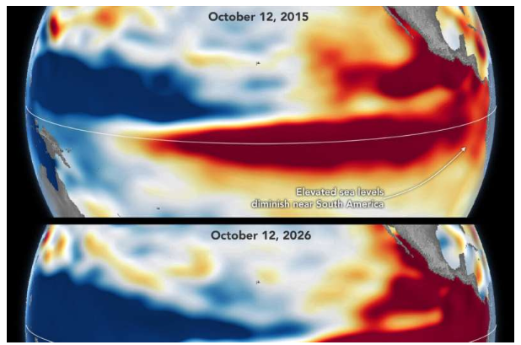
“What's unique about altimetry is that we have a 35-year record from nearly identical satellites flying almost the same ground track, with each mission overlapping the next," Willis said. "That lets us look back in time and compare this El Niño to what happened in 1997. And right now, this one is on track to be even bigger.”
Mestri, S. 2026. El Niño then and now Phys.org October 23
Apostrophe catastrophe

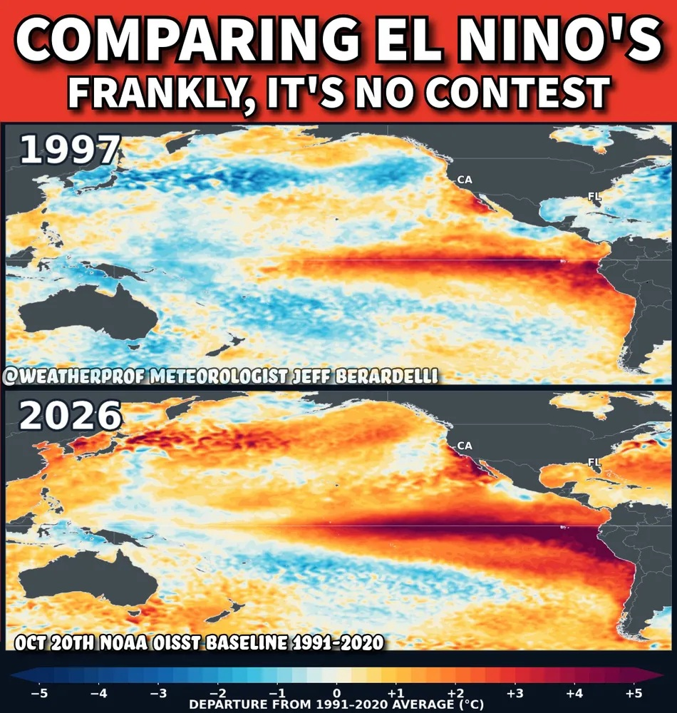
Image via Jeff Berardelli @weatherprof.bsky.social
- its* the end of the world as we know it!
(sorry “it’s”)

Round the world
Africa
After more than three years of war, a lull in fighting raised hopes that a good harvest would ease hunger in Sudan. Instead, El Niño has delivered a damaging drought and, in some areas, led to the lowest rainfall since 1984, the year famine devastated Sudan and Ethiopia…
"The situation today is in most respects much, much worse because of the conflict," said famine expert Alex De Waal, adding that in the 1980s the world mobilised aid resources, while international aid budgets have now been cut back.
Back in 1984, harvests failed, livestock died and people were forced to migrate, said Sirajaldin al-Tahir, a farmer in Um Ruwaba. "But God took pity on us, and the US government brought in aid and distributed it to our village," he said.
"This year, 2026, we don’t know how it will end."
Eltayeb Siddig, Nafisa Eltahir, Khalid Abdelaziz and Olivia Le Poidevin 2026. New famine risk haunts war-torn Sudan with El Niño-driven drought. Reuters, October 23
****
“A coming catastrophe is foreseeable. Its worst outcomes are still avoidable but the window to prevent them is closing. Donor choices will determine whether the predictable weather pattern of El Niño unfolds into a humanitarian catastrophe. Hunger is not inevitable and cannot be blamed on weather alone when the tools to predict and fight food insecurity are at our fingertips. El Niño is arriving at a time of intense precarity. Global estimates show that acute food insecurity has not come down from its 2022 peak — from 258 million people to 266 million in 2025, a rise of 3% despite a collapse in data collection coverage — while the funding to meet that need has fallen by 68% over the same period.
While needs are increasing and funding is decreasing, women and girls absorb the sharpest edge of every shock,and the women-led organizations that are often the most effective actors at reaching them, are receiving disproportionately low levels of quality funding. While the most cost-effective and humane responses are those that are delivered early or in advance of the predictable crisis, there is still time for well-resourced action to be effective in curbing the worst impacts of El Niño. Recent history bears out this fact: in 2022, when Russia's invasion of Ukraine disrupted grain and fertilizer markets, a surge of international humanitarian assistance — a 39% jump from the year before — combined with diplomatic efforts helped avert a forecast surge toward 620 million people losing at least one meal a day.
That response was not without flaws, but it showed that early, large-scale, coordinated action can mitigate the worst outcomes and save lives. By all accounts, humanitarians cannot expect that the scale of support that was mobilized in 2022 will materialize. Reported food-security sector funding has fallen from $12.9 billion in 2022 to $3.7 billion by mid-September 2026. Meanwhile, the drivers of humanitarian needs like conflict, displacement, and high food and fuel prices are now compounded by renewed disruption to food and energy markets stemming from escalating conflict in the Middle East.iv ”
Care, 2026. You Can’t Blame the Weather: Preventing Hunger in the 2026–27 El Niño. Care, October 2023
****
The latest WMO seasonal climate outlook, issued yesterday, “indicates that the current El Niño event could be unprecedented in strength – literally off the monitoring charts that we have used for the past four decades,” the UN agency’s Secretary-General, Celeste Saulo, told a press conference in Geneva together with the UN Emergency Relief Coordinator, Tom Fletcher. “El Niño will peak towards the end of 2026 but its impacts will be felt long after that,” she added.
Forecasts for the Horn of Africa point to an increased likelihood of heavy rainfall and flooding during the October–December rainy season, while rainfall deficits have already affected parts of the Sahel, Ethiopia, South Sudan and Uganda’s Karamoja region.
National Societies in Africa prepare for El Niño impacts – Red Cross Red Crescent Climate Centre October 22.
North America and South America
“Daniel Swain, a climate scientist with the University of California Agriculture and Natural Resources, says the severe thunderstorms are fueled by the large amount of moisture in the air. He says that moisture comes from the record-warm waters off parts of the West Coast, which are driven by a strong El Niño event and a preexisting marine heat wave (which he attributes largely to human-caused climate change).
“The flooding isn't a surprise, he says, pointing to a prediction he and others made in the spring — that if El Niño materialized according to forecasts, southwestern U.S. could see extreme precipitation events through October.”
Berger, A. 2026. Colorado, Arizona, Utah, New Mexico grapple with flooding : NPR
****
Panama is gripped by a water crisis. A rainy season punctuated by drought, exacerbated by the climate crisis, has ravaged large swathes of the country. El Niño threatens to continue the havoc. In August, the government declared a national state of emergency that will remain in place until June 2027. Authorities forecast rainfall deficits of more than 50% in some regions until December.
Rawnsley, J. 2026. ‘For Panama, it is life or death’: how drought is choking the canal that feeds a nation. The Guardian, October 20

Food for thought
The UK is particularly exposed to climate-related disruptions because of the international nature of its food supply (about 42% of its food is imported).
But these effects are rarely immediate. Many food manufacturers and retailers use risk management techniques to limit their exposure to sudden changes in prices, which can initially shield consumers from international shocks.
The Bank of England made this point explicitly, saying the potential effects of El Niño are likely to emerge gradually, rather than causing widespread food shortages or dramatic price rises.
For the most part, disasters with regard to food supply can be avoided with the right kind of human intervention. Businesses adapt. Farmers change production decisions. Trade shifts towards alternative suppliers. Governments intervene.
El Niño should therefore be viewed as a potential source of risk and volatility, rather than as a confident prediction that UK food prices must rise.
But what happens when several external shocks occur together?
The Bank of England has considered this possibility too, warning that a strong El Niño alongside renewed energy disruption could put much greater pressure on UK food prices.
If extreme weather also affects major shipping routes, the effects on import prices could become stronger still. This is where a climate event potentially becomes a monetary policy problem, as central banks treat El Niño as a factor that may cause them to raise interest rates.
Narhidi, Narmin, 2026. How El Niño could push up your mortgage and grocery bills - University of Exeter News October 23
****
The conflict in the Middle East reveals a fundamental nexus of energy, fertilizers and food, and the major role played by the Gulf in the global context.
The Middle East and Russia account for about half of global net diesel exports — about 2 million barrels/day of that supply has disappeared. Global food prices are impacted in two ways: diesel is an important input cost for farmers, and farmers may direct acreage away from food production to feedstock for biofuels.
The Gulf is a critical chokepoint for global fertilizer supplies. The limitations on passage through the Strait of Hormuz in the spring and summer reduced the amount of fertilizer available, and ongoing shortfall puts new planting seasons at risk. The challenge is particularly acute for sulfur, a key fertilizer input.
The compounding effect of higher energy and fertilizer costs, resilient biofuel-linked demand and El Niño-related weather risk puts pressure on food prices and, ultimately, food security. The risk is increasing, especially for low-income countries, where food costs amount to about half of household spending.
Energy disruption and El Niño: Leading to a global food crisis? | S&P Global
“10 Things to Know About This Very Strong El Niño”

1. This year’s El Niño is expected to be among the strongest ever recorded.
2. The planet will likely hit a new global temperature record this year.
3. This El Niño is arriving on top of a record-breaking marine heat wave.
4. El Niño raises sea level across the eastern Pacific Ocean, and the West Coast is already seeing record-high sea levels.
5. Big waves, increased sea level and storm activity can wreak havoc on the coastline.
6. El Niño makes storms more likely to hit Southern California, but rain is not guaranteed.
7. El Niño shakes up the marine ecosystem, with species changing their range to find cooler, more nutrient-dense or more oxygen-filled water.
8. El Niño is devastating for giant kelp forests in Southern and Baja California.
“I am greatly concerned that with continued ocean warming and the increased likelihood of severe and possibly more frequent El Niños, much of Southern California’s kelp canopy could disappear within my kids’ lifetime,” said Parnell.
9. There are some ecosystem winners during El Niño.
“When upwelling is reduced by El Niño, oxygen levels in the middle depths can increase, which allows species that need a lot of oxygen like tuna to move into those depths and find more food,” said Colleen Petrik, assistant professor of biological oceanography. “Tuna do quite well during El Niño years because they can expand their range horizontally into the eastern Pacific and vertically into these deeper waters that normally don’t have enough oxygen.”
The California Cooperative Oceanic Fisheries Investigation (CalCOFI) has done quarterly surveys of the California current for the last 77 years. Looking at the last combined El Niño and marine heatwave that happened between 2014-16, anchovy increased from record lows to record highs, according to CalCOFI project scientist Rasmus Swalethorp.
“This provided a robust food source for many species that eat anchovy, including adult sea lions and large fish like tuna,” said Swalethorp. “Rockfish also did really well during this last big El Niño, which has helped them further recover from overfishing over the past 20 years.”
10. El Niño can affect the global economic output by trillions of dollars.
(the whole thing is well worth a read)

You can wear the uniform and we can play along… (as per a very old Joe Jackson song)
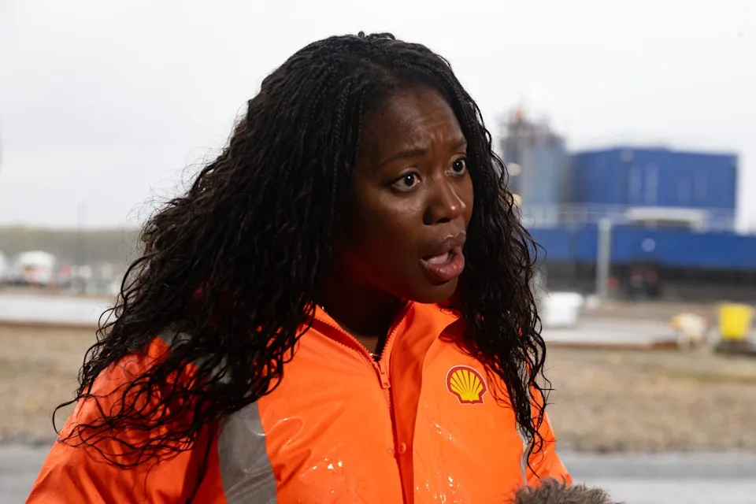

Stuff to watch for in the next week.
The UK Budget on Wednesday. Should be “highly entertaining”…

Videos
The ways 'Godzilla' El Niño is already supercharging extreme weather | BBC News (9m 46)
Fires, floods, and typhoons - the impact of El Niño is already having a significant impact on global weather patterns.
Countries including Indonesia, India and the United States have been experiencing droughts, floods and heatwaves in line with projections about how extreme weather events will be supercharged by the phenomenon.
The World Meteorological Agency says the record-breaking El Niño will strengthen further and persist until at least 2027.
The BBC looks at the different ways its impact is already being felt around the world.

El Nino could be 'literally off the monitoring charts', says UN | AFP (29secs)

Links
For a FAQ see here. The comedy of El Nino (no, really) it’s a 1997 video. El Nino acronyms El Nino quotes
El Nino videos El Nino timeline up to 2025
Disclaimers
I am not a climate scientist. I am mostly collating what other people say, not pushing my own “angle”. I will get things wrong - when I do, I’ll fess up, no fuss. I will quote from “reputable” sources, but sometimes the truth is an outlandish outlier.
Blah blah information provided for lulz only. No responsibility taken for your failure to create broad-based social movements that prevent shit getting even worse and instead leading us into the pit of Sarlac.
The digest is inspired by the awe-inspiring and heart-breaking “CO2 Newsletter published by American geologist William Barbat from 1979 to 1982.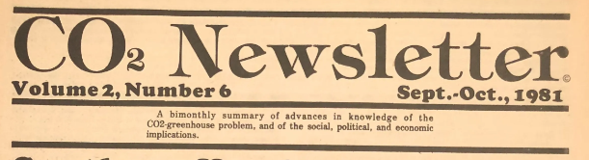

Joke of the Week

(continued from front page!)
Finding the door locked, he peeks in the keyhole and
sees his father having sex with the nanny. He gives up and goes back to bed.
The next morning, the little boy says to his father, "Dad, I think I understand the concept of politics now." The father says, "Good, son, tell me in your own words what you think politics is all about." The little boy replies, "Well, while Capitalism is screwing the Working Class, the Government is sound asleep, the People are being ignored and the Future is in Deep Shit

