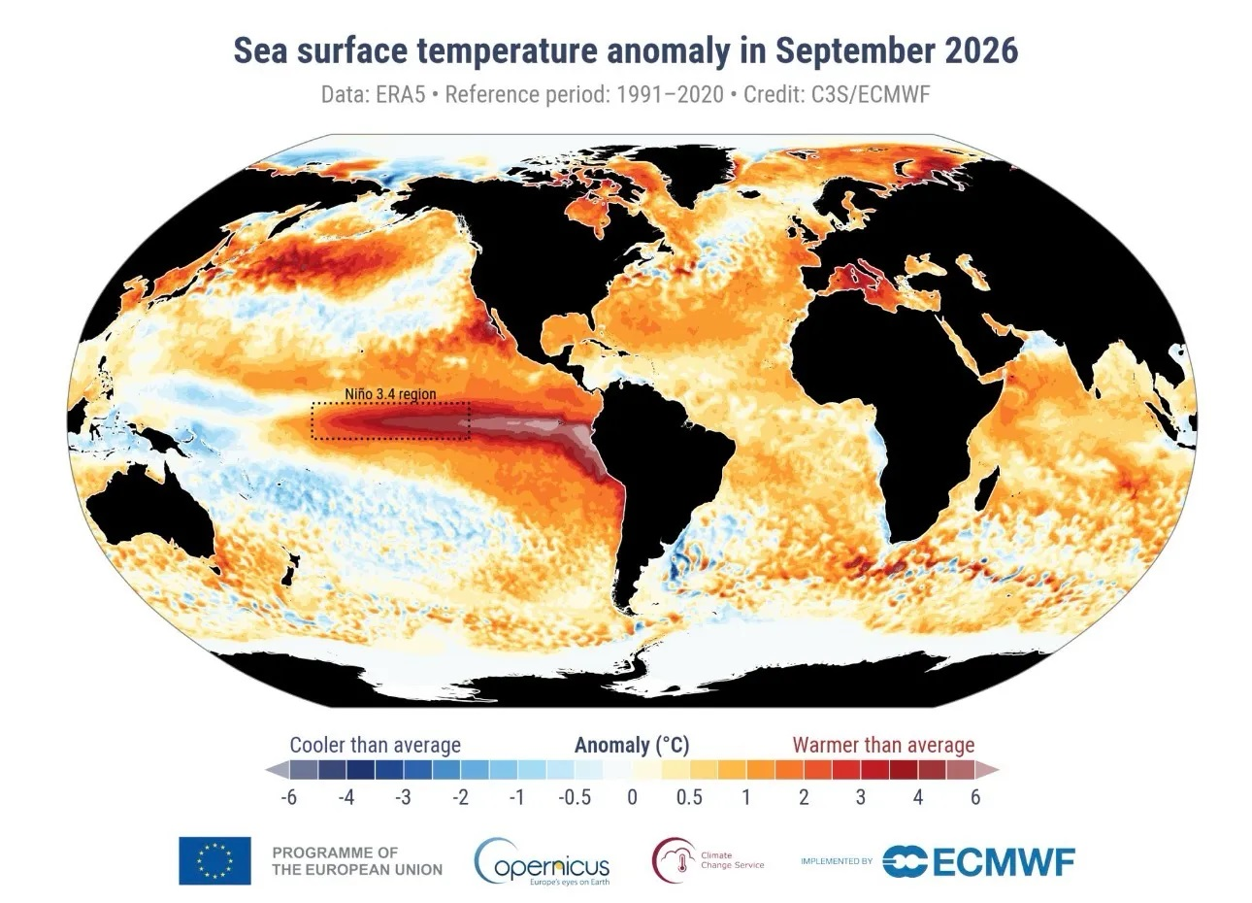
Colour Me

Or “Ocean Colour Scream”...
“Monthly SSTs for September were more than 3°C above average across the central and equatorial Pacific, including much of the Nino 3.4 region. The largest anomalies occurred farther east along the Peruvian coast and west of the Galápagos, reaching 6–7°C above average in those areas.”
https://climate.copernicus.eu/surface-air-temperature-september-2026
Amazed

Joke of the Week
In these dark days man tends to look for little shafts of light that spill from Heaven…. So I propose to share tiny flashes that have illuminated my sombre life and… have a joke per issue, as far as possible, El Niño or weather-themed.
What do you call a woman who sits at her kitchen table setting fire to her bills, IOUs and council tax demand?
Answer on the last page of this issue.

Welcome to the 5th of at least 7 weekly issues of the El Niño Digest Times (END Times - geddit?). The why should be self-explanatory, but here’s a FAQ just in case. We are still just about in the first of the three phases of El Niño but not for long…

Here’s the database I’ve begun (but almost certainly will not maintain). It’s largely based on two Google Alerts for “El Niño” and “Impacts” and “Godzilla”. Plus things people (like you) send me.

There are a lot of good El Niño explainers out there - this one, by Al Jazeera is really good and I will link to it at the top of every digest until someone suggests a better one (ideally with the url written on a £50 note).

Editorial
I just today (Saturday 17th) read Flannery O’Connor’s short story “A Good Man is Hard to Find.” You can find it online here. It was published in 1953 (by coincidence an extremely important year for climate science - Canadian physicist Gilbert Plass made his presentation about the long-term implications of carbon dioxide build-up at the American Geophysical Union in May of that year, and it went ‘viral’). Spoilers ahead: it concerns a family on a vacation trip through the Deep South against the knowledge that there is an escaped - and armed - ‘madman’ on the loose. The family disregard the warnings, fail to do the sensible things and are undone by childish actions (does any of this sound at all familiar?) I am drawing a long bow here, of course. In no reasonable way can this short story be read as “anthropocene fiction” (though doubtless an ambitious honours or Masters student could give it a red-hot try.
Suffice (sic) to say that there comes a point, after an accident, where you can mewl all you like about the unfairness of it all, how it coulda shoulda been different, but whatever you say, you are STILL looking down the barrel of a (literal, in the story) gun, and that is all there is too it, possible moments of grace or not aside. It is what it is.
Next week, I will somehow find a way to editorialise on the book I just bought in the charity shop - the Jungle Book (“Do you like Kipling?” “I don’t know, I’ve never kippled…”)

Well, this is exciting…
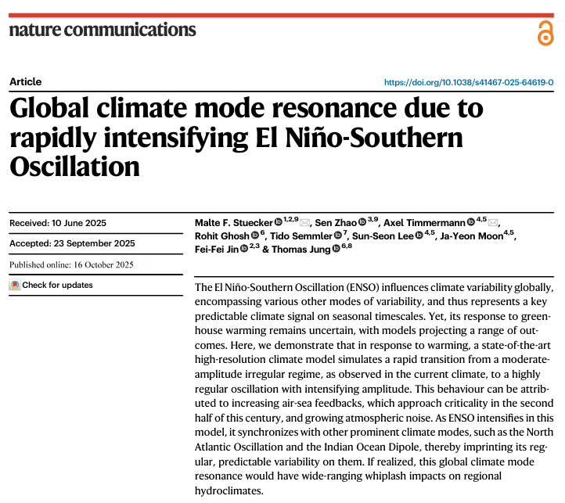
LINK. Short version seems to be “don’t be surprised if Godzilla doesn’t come back more regularly, bringing his friends.”

The three phases of El Niño

- The Antici…pation
From early this year until … (looks at watch)... about now. Scientists saying they’ve double-checked and triple-checked and they’re as sure as they can be. Disaster management folks pleading for money and decent plans. Politicians telling us to stock up, or declaring States of Emergency in advance, with an eye on their 2028 Presidential run… Journalists writing SEO-ed disaster porn speculations. Everyone holding their breath, putting their fingers in their ears to not hear the Doomers gloating “I told you so.”
- “Then someone yelled out ‘Contact!’”
The rolling roiling disasters, especially salient when (rich) White People in Peril can be filmed. The shark in the shopping mall meme resurfaces. The re-insurers point to their fine print, and some insurers go belly-up. The rich libertarians squeal for state bail-outs. Food prices through the roof. Hard-to-replace infrastructure washed away.
- Back to the perfect paradise
The wreckage is quietly swept away, the global machine reboots, and the important (rich white) people continue their merry way. The End. (Actual outcomes may vary; always read the label).

Quotes of

El Niño’s added ocean heat affects the atmosphere, causing weather patterns around the world to shift. Consider it kind of like a domino run, where one tile starts a chain reaction. Such a major slug of heat in the Pacific will act more like a shove then a light flick on the atmosphere, and the resulting shifts in weather are expected to be generationally intense.
Gonzalez, F. 2026. Let’s Talk About the Super El Niño and Climate Change. Wired, October 11

“Since September 20th, when Odalys formed, it’s been berserk,” said Colorado State University researcher Phil Klotzbach, who forecasts and studies storm activity. “This year just everything that forms is just lasting a long time and getting really powerful.”
Borenstein, S. 2026. El Niño powers Pacific hurricanes to record activity for strength, longevity | AP News October 13

“For children, El Niño is far more than a weather pattern. It can mean increased displacement, malnutrition, water shortages, and disease outbreaks. Children are also at risk of schools closing, while families could experience added financial hardship," Catherine Russell, who heads the agency, said.
Unicef, 2026. UNICEF Fast Facts: Over 347 million children in nearly 100 countries will be exposed to one of the strongest El Niño events on record. Unicef, October 6

“Most of us climate change ecology people are kind of perversely excited about it,” says John Bruno, a marine ecologist at the University of North Carolina at Chapel Hill. “It’s an experimental treatment that nature is providing to us.”
Cornwall, W. 2026. This year’s ‘super’ El Niño could wreak ecological havoc worldwide | Science | AAAS October 13

the Week

Whether this “super” El Niño will translate into superdamage around the world remains to be seen. Other ocean phenomena, such as water temperatures in the Indian Ocean, can either moderate or amplify an El Niño’s effects, says Chris Funk, an applied climatologist at the University of California, Santa Barbara whose work focuses on developing weather forecasting tools to predict drought, famine, and other natural disasters. He says the indicators so far point to a wild ride for people and ecosystems. “The pretty obvious conclusion is that we should buckle up.”
Cornwall, W. 2026. This year’s ‘super’ El Niño could wreak ecological havoc worldwide | Science | AAAS October 13

Ian Lisk, a chief meteorologist at the Met Office, warned attendees of a recent Airports UK annual conference that “we don’t get normal weather any more, fundamentally…. None of this is good news. The heatwaves and the events of this last summer had nothing to do with El Niño.”
Glover, A. 2026. El Niño, Polar Vortex: There's 'No Normal Weather' Anymore | HuffPost UK Life October 15

"If you go to one demonstration and then go home, that's something, but the people in power can live with that. What they can't live with is sustained pressure that keeps building, organizations that keep doing things, people that keep learning lessons from the last time and doing it better the next time."
Noam Chomsky

Money
(always the 5th element, whatever Aristotle thought)

“Developing countries face a triple shock from the energy crisis, El Niño and surging borrowing costs and need urgent support from the international community, the UN’s development arm has warned.
“Speaking before the International Monetary Fund (IMF) and World Bank annual meetings in Bangkok this week, the UNDP’s administrator, Alexander De Croo, called for “solidarity and global action”.
“Developing countries, their hands and legs are being pulled in different directions: it’s truly hard for them,” he said.
“Before the meetings, the UNDP published a report, No Time to Recover, which lays out the risks of what it calls the “compounding crises” of energy, climate and debt.”
Stewart, H. 2026. Developing nations face triple shock from energy crisis, El Niño and borrowing costs, UN warns. The Guardian, October 11

“BANGKOK — The Philippine central bank is planning for a “Godzilla” El Niño on top of a prolonged oil shock, as the Southeast Asian nation tries to rein in inflation from three-year highs.
Governor Eli Remolona said Bangko Sentral ng Pilipinas now sets policy using scenarios that factor in oil prices and the severity of the weather event. “We have the regular, ordinary El Niño, which is bad, and then we have the Godzilla El Niño, which is really, really bad,” he said Wednesday on a panel at the IMF and World Bank annual meetings in Bangkok.”
Bao, A. 2026. ‘Godzilla El Niño’ is wreaking havoc with Philippine central bank’s inflation forecasts. CNBC, October 14

“The arrival of the 2026/27 El Niño brings renewed uncertainty to Brazil's agricultural sector, with regional impacts varying widely. Central and Northern areas face higher risks of heatwaves and below-average rainfall, while the South is bracing for excessive precipitation. These shifts threaten to disrupt planting schedules for soybeans and second-season corn, reduce water availability for pastures, and strain livestock welfare. High temperatures may also jeopardize critical coffee and orange flowering periods as well as sugarcane yields. In response, Brazilian producers should be prepared for elevated input costs, rising insurance premiums, and recurring infrastructure vulnerabilities associated with severe weather events. These financial impacts may have lasting effects well into future harvests, heightening the strain on Brazil’s agricultural sector.”

Brazil: Bracing for Impact - How the 2026 El Nino Affects Brazil's Agriculture Attaché Report (GAIN) | BR2026-0040

“In this paper I use a new approach to estimating the impulse response functions of El Niños. I find that El Niños pose material upside risk for PCE prices and employment. The longer-run price effects are driven by core services and food prices and depend on whether La Niñas follow El Niños, a very common occurrence. After modest offsetting initial effects, employment increases are widespread in terms of both sectors and states in the year following the El Niño. These results indicate El Niños can have material impacts on the US.”
Roth Tran, Brigitte 2026. “In Hot Water? The Macroeconomic Impacts of El Niño.” Federal Reserve Bank of San Francisco Working Paper 2026-21. https://doi.org/10.24148/wp2026-21

Don’t go visiting waterfalls…
“Heavy rainfall fuelled by a supersized El Niño weather pattern briefly forced Argentinian authorities to close tourist access to the famed Iguazu Falls, amid fears that rapidly rising water levels would cause the river to burst its banks.”
Anon, 2026. Argentina temporarily closes Iguazu Falls after El Niño-fuelled surge in water levels. The Guardian, October 13.

Around the world
Africa
The effects are already being felt. In Somalia, heavy rains have flooded parts of Mogadishu and damaged health facilities, echoing the El Niño-linked floods of 2023 that displaced 1.2 million people.
Who will be most affected by El Niño? How to help | International Rescue Committee

Asia
PETALING JAYA: The meteorological department has forecast scorching weather between March and May next year due to the Super El Nino phenomenon, potentially breaking Malaysia’s record high temperature of 40.1 degrees Celsius.
Its director-general Hisham Anip said Malaysia’s maximum temperature could exceed 41 degrees Celsius based on an analysis of the current El Nino phenomenon, alongside the impacts of climate change and global warming.
“If we look at current climate change trends, the rate of temperature increase in the country is approximately 0.13 degrees Celsius per decade.
Anon, 2026. Super El Nino in 2027 could break Malaysia’s 40.1°C record. Free Malaysia Today, October 13
Japan
The Japan Meteorological Agency says Japan can expect higher-than-usual temperatures this winter.
Skiing facilities are expressing concern over a potential warm winter.
Snow-making equipment requires subzero temperatures to work properly.
The manager suspects ski resort operators across the country are worried.
He says they may have to consider different approaches depending on the situation.
However, experts emphasize that they cannot say with certainty that it will not snow.
Global implications of extreme weather phenomenon | NHK WORLD-JAPAN News

India

The degree of difficulties may vary between states, but the fact that around 40 per cent of India’s landmass spread over 15 of the 36 states and Union Territories received less than normal rainfall will remain a matter of concern…
“India is well placed with its foodgrain stocks — a massive pool of 602 lakh metric tonnes of wheat and rice — three times the prescribed buffer stock. Food will not be a problem even if India experiences a rare second successive failure of SWM season in 202, as a section of meteorologists fear. India’s real problem is drinking water supply in states that ended up with serious deficit rains and irrigation for agriculture.”
Anon, 2026. El Niño-driven Drought Poses A Major Challenge Deccan Chronicle, October 13

Food security

International Monetary Fund chief Kristalina Georgieva told AFP she is "very concerned" about El Niño's global impacts, particularly on food security. The IMF is "getting ready" to offer support to countries that may struggle to absorb the impact, she added. The United Nations Development Programme also warned Sunday that the combined impacts of higher borrowing costs, surging energy prices and the powerful El Niño created "a perfect storm that could throw tens if not hundreds of millions of people back into poverty."
Hussein, S. 2026 El Niño watch: The impacts around the world this week

United Kingdom

Londoners are being urged to sign up for flood warnings amid growing concern that extreme weather fuelled by a “Godzilla” El Niño will batter the UK this winter.
Flood action online is designed as a one-stop shop for people to understand the flood risk to their homes and take action to reduce it, as well as providing easy access to weather alerts from the Met Office during incidents.
Howe, M. 2026. Londoners told to sign up for flood warnings amid Super El Niño extreme weather fears | The Standard , October 13

Up to 1.7 million UK households will not turn on their heating this winter in an effort to save money - as a record El Niño threatens to unleash extreme weather this winter.
A poll for Uswitch suggested that as many as 1.7 million households will turn off their heating to save money on costs, with only 40% planning to turn it on if they get too cold.
Yadav, N. 2026. 1.7 million Britons 'won't turn on heating' this winter amid Godzilla El Niño extreme weather threat. The Standard, October 14
“Colder, calmer weather in UK winters is known to present a challenge for energy production from renewable sources, especially when it is also cloudy. Wind power generates 40% or more of the UK’s electricity during winter, and cold, calm periods can require more gas power to make up for lower wind generation and increased demand for heating.”
Brimicombe, C. 2026. A record-breaking El Niño is still developing – likely bringing a cold winter to the UK The Conversation, October 14

UK weather tends to be less directly affected than other areas of the world, but due to the strength of this El Niño the extent of the forecasts suggest there is an increased likelihood of wetter and stormier conditions during autumn and early winter, alongside a slightly increased risk of colder weather and cold snaps later in winter.
What’s likely around the winter peak from October to December 2026:
- Increased likelihood of stormier conditions
- Increased likelihood of heavy rainfall and flooding
Early 2027:
- Slightly increased likelihood of 'cold snaps'
In the UK this could cause:
- Flooding
- Power cuts
- Damage by high winds
- Snow and icy conditions
These events are something the UK experiences every year. While El Niño does not directly cause individual storms, floods or cold weather events, forecasts suggest it could increase the likelihood of some weather patterns that make these impacts more likely.
With around 50% of UK food imported, including 80% of fruit and vegetables from countries such as Spain and Morocco, supply could be impacted by events in countries of origin, which would have a knock-on effect for UK shoppers of driving up prices and scarcity. This is especially true for foods that can only be grown and cultivated in certain areas of the world.
These include foods like:
- Rice
- Cocoa
- Coffee
Red Cross, 2026. El Niño and the UK: How the 'Super' El Niño could affect weather, flooding and food prices (Lots of good prepping advice, btw)

“We are a long way behind in terms of what is needed for adaptation as a country. The very hot summer we have just had has alerted people to what has been coming for a long time. It is going to get worse than this,”
James Richardson, the chief analyst at the Climate Change Committee
Glover, A. 2026. El Niño, Polar Vortex: There's 'No Normal Weather' Anymore | HuffPost UK Life October 15

Bowel-loosener of the Week
Not long ago the idea of a book on Amazon forest fires would have seemed as absurd as a book on Amazon snowstorms, according to Erika Berenguer, a senior research associate in Oxford University and Lancaster University and an expert on human-driven disturbances in the world’s biggest tropical forest. “Fires just didn’t happen before because the forest was too humid,” she explains.
But decades of deforestation and climate disruption have changed that completely. Swathes of the Amazon are now drier and more flammable, particularly in El Niño years which are associated with lower rainfall.
Watts, J. 2026. How to fight El Niño-boosted fires in the Amazon - SUMAÚMA October 13

Videos
Green Pulse (Singapore) Haze and a Godzilla El Nino: How is Singapore preparing? (31 mins)

Synopsis: Every Tuesday, we discuss how environmental issues intersect with business, politics and society.
After three years of clear skies, the haze is back in Singapore. One contributor to the pollution is the El Nino weather phenomenon, which causes drier, hotter weather in South-east Asia.
Super El Niño 2026 I 2.7–3°C Warming I Will 2027 Be the Warmest Year | IPCC 7th Assessment Report (49 mins)
Science Talk: In this episode of Science Talk podcast, we sit down with Dr. Zeke Hausfather (https://thebreakthrough.org/people/ze..., a leading climate scientist known for translating complex data into clear, accessible insights. While not a “typical academic,” he holds a PhD and has played a major role in advancing public understanding of climate science. He is currently affiliated with Berkeley Earth (https://berkeleyearth.org/team/) and is also working in the private sector on carbon removal solutions.
This wide-ranging conversation tackles some of the most urgent and debated questions about our planet’s future. What exactly is happening to Earth’s climate—and why? Do we now have enough evidence to definitively prove that climate change is real? We also explore the growing discussion around whether 2027 could become the warmest year on record, especially in the context of a potential Super El Niño.
NASA Satellites Observe Historic 2026 El Niño
Turns out, with satellites, we could see it coming

Simon King of the BBC has a good explainer abt weather records getting broken

CNN is okay on six myths: Six things scientists say you need to know about El Niño | CNN

Links
For a FAQ see here. The comedy of El Nino (no, really) it’s a 1997 video. El Nino acronyms El Nino quotes
El Nino videos
El Nino timeline up to 2025
Disclaimers
I am not a climate scientist. I am mostly collating what other people say, not pushing my own “angle”. I will get things wrong - when I do, I’ll fess up, no fuss. I will quote from “reputable” sources, but sometimes the truth is an outlandish outlier.
Blah blah information provided for lulz only. No responsibility taken for your failure to create broad-based social movements that prevent shit getting even worse and instead leading us into the pit of Sarlac.
The digest is inspired by the awe-inspiring and heart-breaking “CO2 Newsletter published by American geologist William Barbat from 1979 to 1982.
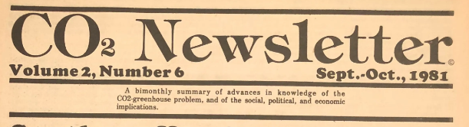
That joke!

Bernadette! Ba-doom, tish.
What do you call a hairless murder ape using its opposable thumbs to dig up coal and set fire to it?

Bernaplanette.

Excerpts from an interview with Amy Westervelt
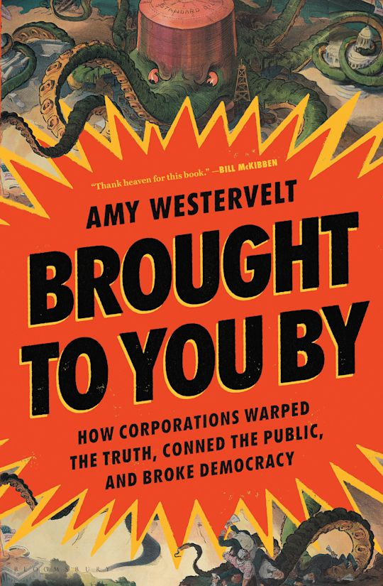
3. What is “Drilled”, how did it come to be and why should everyone listen to it?
Drilled started out as a true-crime podcast about climate change and is now a global newsroom producing both the podcast and cross-border investigations into climate obstruction with a wide range of partner outlets.

It started out because I had been a longtime climate reporter in print and was wishing I could do radio and then thought well I probably could if I learned how, so had gone to work for a radio station. They had trained me in audio reporting, but I was still working as a climate reporter, at the time mostly for The Guardian where I worked on retainer for several years. There was a bit of a narrative podcast boom at the time, driven primarily by the podcast Serial, and I thought there should be something narrative on climate–only a handful of climate pods existed and they were all interview-based, not stories. But I couldn’t think of something that could carry a whole podcast season either.

Then I got assigned to cover one of the early climate liability cases in California, where the cities of Oakland and San Francisco were suing some of the world’s largest oil companies for their role in delaying action on climate change and thus increasing the costs of adaptation for cities. The judge in that case had called for a climate science tutorial — he was an eccentric guy, known for such things – and both legal teams showed up in San Francisco prepared to present on who knew what, when, and what they’d done with that information. All the characters were there: The eccentric judge, the scientists, the slick oil company lawyers, the activists, and I thought “aha! that’s it, I’ll make a true-crime podcast about climate change.”

At the time, people weren’t really talking about climate as a crime so it was somewhat novel and I thought it was a great idea, but none of the podcast companies were interested. They all said there wouldn’t be enough of an audience. I was really convinced they were wrong so I made it anyway with an audio engineer friend and a small seed grant from a nonprofit, and we wound up getting a million listens to our first season, so that proved that there was an audience. By that point I had ideas for the next three seasons and now we’re working on Season 18.

4. This book – how did it come to be? What is it trying to achieve? What does it do that other books (Ross Gelbspan, Oreskes and Conway) that have looked at climate propaganda didn’t do?
It had a very circuitous path!... The idea I initially pitched him was a whole book on Herb Schmertz, the legendary VP of public affairs for Mobil, and one of these days I still want to write that book. BUT understandably he thought it was a bit too niche. So we bounced ideas around for about a year and basically co-wrote the proposal for the book. Which is highly unusual! I felt like other books had focused on one particular type of propaganda — science denial or PR or lobbying — but none had looked yet at how it all works together. I also thought there’d been this tendency to frame this issue as though one industry figured this stuff out and then another industry copied it, which didn’t jive with the documentation I’d seen. I think it’s helpful for people to see how this works across industries and how these strategies were really concocted to help all industries and companies avoid regulation and get around democracy in a variety of ways.

6. I’ll give you five minutes with Prime Minister Andy Burnham. Let’s say he’s read your book. What ELSE would you say to him?
I’d tell him to talk to Tessa Kahn of Uplift about why everything he’s said about North Sea oil is wrong

8. Any shout outs to other climate journalism, journalism full stop – people who deserve more attention than they are getting?
Always! Let’s see, well first I want to make sure to shout out all the other reporters working with Drilled – Alleen Brown, Royce Kurmelovs (who is single-handedly producing a massive amount of Australia’s investigative climate journalism), Nina Lakhani, Diana Taremwa-Karakire in Uganda, Rishika Pardikar in India, Alice de Souza an excellent Brazilian journalist living in the UK, Ana Dominguez in Argentina, Jose Catalayud in Spain, Alex Brutelle in France. Then I think the folks at the Intercept Brasil are some of the best journalists around. Sharon Lerner does incredible work at ProPublica. Hilary Beaumont all over the place, Sara Sneath at The Guardian. Kendra Pierre-Louis has been doing amazing climate reporting for years. I know I’m immediately going to kick myself for forgetting someone.

