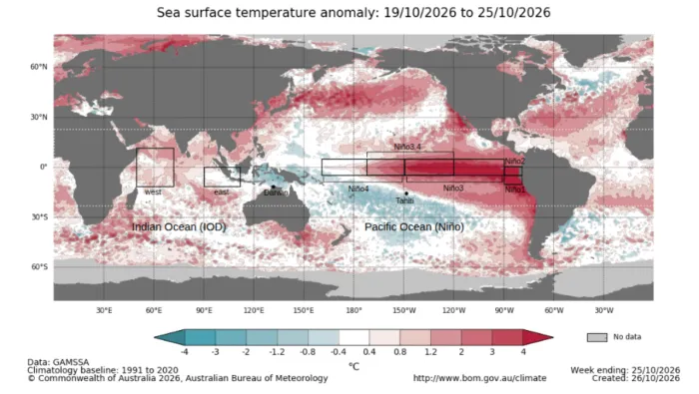
RED IT

The frogs are boiling…
“The El Niño climate phenomenon reached an unprecedented weekly sea surface temperature anomaly of +3.4°C in the central equatorial Pacific during October 19-25, 2026, according to NOAA data analyzed by Meteored Brasil on October 30. The reading is the highest absolute weekly anomaly reported in the historical series beginning in 1981. The development matters for U.S. agriculture because exceptionally warm Pacific waters can alter atmospheric circulation, potentially affecting crop yields, drought exposure, livestock operations and commodity markets as farmers prepare for the 2027 growing season.”
Could Super El Niño Bring Record Farm Risks in 2027?

& WEEP

Joke of the Week (about emissions)
A couple are at a marriage counsellor for their first visit. After 20 minutes he takes off his glasses, pinches the bridge of his nose and says, “look, I’ve never in all my decades met a couple with such communication issues. We could try prolonged sessions of therapy, but I fear they would be futile. I am tearing up the rule book here, but sir, would you be willing to talk to your wife” - the counsellor hesitates “while you’re making love?”
The husband ponders for a second, then shrugs and says “sure, if I’ve got my mobile with me, why not?”
Welcome to the 7th weekly issue of the El Niño Digest Times (END Times - geddit?). The why should be self-explanatory, but here’s a FAQ just in case. We are still just about in the first of the three phases of El Niño but not for long…

Here’s the database I’ve begun (but almost certainly will not maintain). It’s largely based on two Google Alerts for “El Niño” and “Impacts” and “Godzilla”. Plus things people (like you) send me.

There are a lot of good El Niño explainers out there - this one, by Al Jazeera is really good and I will link to it at the top of every digest until someone suggests a better one (ideally with the url written on a £50 note).

Editorial
Well, what can you say about our species? I come back time and again to a climactic (ha ha) scene in the 1996 film Arrival (so, spoilers, obvs). It stars Charlie Sheen as a NASA scientist (yeah, I know) working for the “Search for Extra-Terrestrial Intelligence” (SETI) program. Long-story short, he’s found out that aliens are already on earth and are hard at work terraforming it. They are essentially galactic real estate agents trying to get a better price. The confrontation between him and his former SETI boss (an alien in a skin suit, there to stop the hairless murder apes from realising they’d already been invaded) is mint. The boss (played by the late Ron Silver, who went horribly right-wing after 911, but I digress) is told by Charlie Sheen that what the aliens are doing is wrong, immoral.
Ron Silver replies (I paraphrase) “How? Why? We are merely accelerating a process which you humans began, are perfectly aware of and are doing absolutely nothing to stop. Where’s the immorality?”
Sheen has no answer to this, and I don’t know that I would in the same circumstance. We have all these fine words about ‘rights’ and ‘progress’ and so on, but ultimately, Silver is right, at least for the subset of ‘high-tech’ humans who are currently running the show. Others might point to subsistence hunter-gatherers living in ‘balance’, but a critic might then point to the rather rapid disappearance of the megafauna (big slow lumps of protein, nom nom nom) when the humans turn up.
Anyway, this is all a bit ‘off topic’ for El Nino, which is after all, merely a weather pattern, albeit one that is going to reveal where things are up to and possibly accelerate them a bit. We are now into the second phase of it all (see opposite column) and can expect all sorts of horror (see page 8 stop press).
This be the worst
(with apologies to Phil Larkin)

They fucked the Earth, your mum and dad
They didn’t mean to, but they did
They filled the air with carbon - bad!
And of other species they got rid

But they were fooled into the burn
By PR flaks with loads of cash
Who half the time did denial-gurn
And elsewise sold the techno-flash

Man hands on apocalypse to man
It billows like a toxic cloud
There’s absolutely no b-plan
Having kids should be disavowed.

The three phases of El Niño

- The Antici…pation
From early this year until … (looks at watch)... about now. Scientists saying they’ve double-checked and triple-checked and they’re as sure as they can be. Disaster management folks pleading for money and decent plans. Politicians telling us to stock up, or declaring States of Emergency in advance, with an eye on their 2028 Presidential run… Journalists writing SEO-ed disaster porn speculations. Everyone holding their breath, putting their fingers in their ears to not hear the Doomers gloating “I told you so.”
- “Then someone yelled out ‘Contact!’”
The rolling roiling disasters, especially salient when (rich) White People in Peril can be filmed. The shark in the shopping mall meme resurfaces. The re-insurers point to their fine print, and some insurers go belly-up. The rich libertarians squeal for state bail-outs. Food prices through the roof. Hard-to-replace infrastructure washed away.
- Back to the perfect paradise
The wreckage is quietly swept away, the global machine reboots, and the important (rich white) people continue their merry way. The End. (Actual outcomes may vary; always read the label).

QUOTES OF

THE WEEK
In 1877, when crops failed and an estimated thirty million people died in India, China and Brazil, El Niño was the cause. In 1997 another El Niño event brought crippling drought to South Africa, downpours in Ecuador and destructive ice storms in New England and Canada. In 2015 record hurricanes were seen in the north Pacific and in Antigua a billion-gallon reservoir ran dry.
Those were devastating years. But this year is expected to be far worse.
Oct Nov
El Niño has sucked huge volumes of water to South America, which is coping with severe flooding, and left southeast Asia in drought.
Indonesia is living through its worst fires since the last El Niño in 2015, with nearly two million hectares burning and no end in sight.
December and January
Both American coasts are expecting heavy rain and fierce storms. California has already declared a state of emergency. Drought is forecast in the Amazon.
February and March
Africa is expected to face brutal effects by the spring: 70,000 deaths are projected from drought, famine and flood.
Somalia, which saw 1.2 million people displaced by the El Niño floods in 2023, is already experiencing heavy rain which is expected to worsen over the coming weeks. Southern Africa is braced for drought and crop failures.
El Niño is here: what is it and what will the impact be? - The Times Oct 24

“The polar vortex is about to undergo an unusually early stretching while super El Niño is still intensifying, competing for influence on weather in the U.S. and Europe later in November and December.”
Erdman,J. 2026. An early polar vortex? What super El Niño says about it. Weather.com October 28

“ El Niño can be compared to a highway with weather phenomena like the vehicles on it. El Niño does not let us predict the speed of a particular vehicle, nor the lane it's in, and sometimes vehicles suddenly exit or enter the highway," Michelle L'Heureux, a physicist at the U.S. National Weather Service, NOAA, told AFP. "Similarly, the specific characteristics of weather phenomena will be influenced by factors other than El Niño," she said.

"However, El Niño can make certain weather events more or less likely over the course of a season. We simply can't attribute an entire weather phenomenon or associated extreme event solely to El Niño, because other factors also play an important role.

Bekhtaoui, A. 2026. El Niño watch: The impacts around the world this week. Phys.org Oct 27El Nino creates significant public health challenges ranging from heat-related illnesses to infectious diseases.

Persistent high temperatures during El Nino can cause severe health conditions and worsen chronic illnesses.

Unpredictable rainfall patterns cause water scarcity and flooding that elevate the risk of water-borne diseases..

Banerjee, S. 2026. How El Niño impacts public health: From disease outbreaks to extreme heat … The Week (India), October 27 The author is a critical care specialist, diabetologist, and metabolic health expert.

The WMO Greenhouse Gas Bulletin reported that the globally averaged surface concentration of CO₂ in 2025 was 426.8 parts per million, or 153% of the 1750 pre-industrial baseline. Concentrations of methane and nitrous oxide - the second and third most important long-lived greenhouse gases related to human activities - also rose to a new record.

https://wmo.int/news/media-centre/greenhouse-gas-levels-once-again-reach-record-high

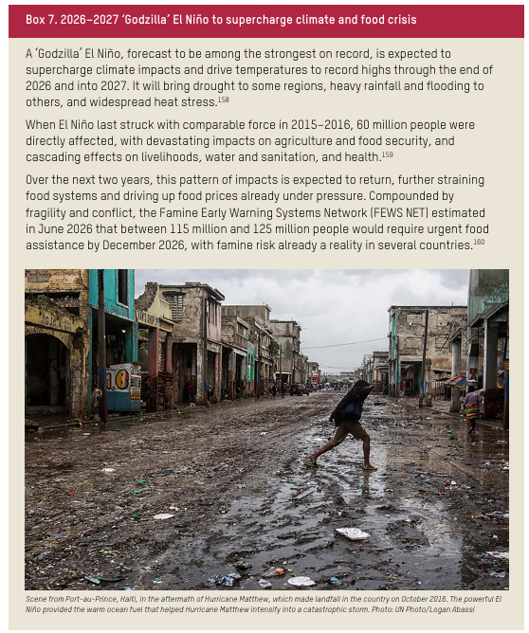
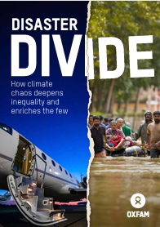

Disaster Divide: How Climate Chaos Deepens Inequality and Enriches the Few | Oxfam International

Round the World

Smoke from rampant peatland wildfires fueled by a record-breaking El Niño has engulfed Indonesia and much of Southeast Asia in a toxic haze. As the blazes diminish air quality by releasing hazardous pollutants, they are also emitting massive amounts of planet-warming carbon. So far this year, Indonesia’s fires have released an estimated 190 million tons of carbon. That’s roughly equivalent to three-quarters of the country’s annual CO2 emissions from burning fossil fuels, according to Earth scientists Gareth Roberts and Martin Wooster. In an article for The Conversation, they explain how El Niño-driven drought set the stage for the current crisis.

Lapointe, E. 2026. Global CO2 Levels Expected to Surge Thanks to This Super El Niño. Gizmodo, October 30

When water sources run dry or floods disrupt daily life, the costs extend beyond damaged homes and lost crops. For women and girls, they can mean longer working hours, lost income and less time for school, healthcare or rest.

“Climate hazards, such as droughts, floods and heatwaves, do not affect all people equally. Rather, these climate shocks magnify and expose the structural inequalities deeply entrenched within society,” Ma. Rosalyn Mesina, country programme coordinator of UN Women Philippines, told Eco-Business.

Women and girls often manage water collection and unpaid care while also earning livelihoods, she said. When drought, heat or disrupted services add to those responsibilities, the result can be longer hours of physical work, lost income and less time for healthcare or rest.

Albay, R. 2026. ‘Heat is no equaliser’: Eco-business.com , October 30

In the Amazonian region of Serra Grande in Brazil, about 50 kilometers (31 miles) from the state capital, Boa Vista, the seasonal waterfall known as Véu de Noiva usually draws visitors from May through early September during Roraima’s rainy season. That changed in 2026. By late July, the water that defines the landscape had already vanished.
Fábio Wankler, a geologist and professor at the Federal University of Roraima (UFRR), points to a “super El Niño” as the driver behind the disruption. The phenomenon, unusually intense this year, has triggered a series of shifts in weather patterns that, across various parts of the country, “have caused longer and more intense periods of drought,” he said.

Medeiros, F. 2026. ‘Already feeling it’: Northern Amazon waterfall season ends early, hurting livelihoods. Monbabay, October 29

“This fall and winter will feature the naturally occurring king tides, which occur when the Earth, moon, and sun come into alignment, resulting in the year’s highest water levels. Just the king tides alone add about 1-2 feet to average high tides.
“But this is also a very important year: tidal cycles that peak every 4.4 years and every 18.6 years are both, unfortunately, expected to peak this year, bringing even higher king tides than usual. According to Patrick Barnard at UC Santa Cruz, this would result in an extra 2-4 inches of sea level rise this winter, on top of the already 1-2 feet increase from king Tides, with repeated peaks around Thanksgiving, Christmas, and MLK Day, around the successive full moons.”
Alessi, M. 2026. Super El Niño and Fossil Fueled Climate Change Are Compounding Record High Sea Levels in California. Here’s How. The Equation (Union of Concerned Scientists), October 27

King Canute lives!!

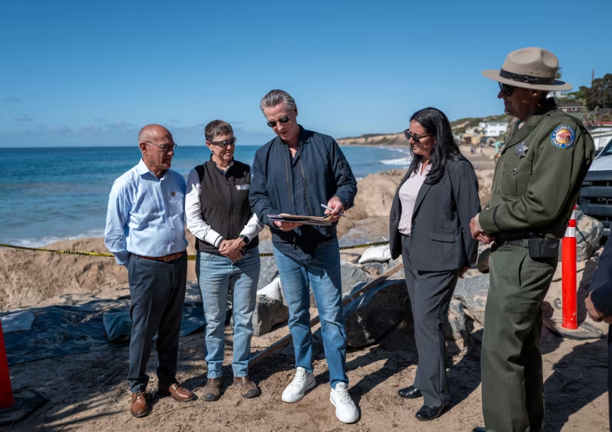
California Gov. Gavin Newsom signs an executive order to protect the state’s Pacific Coast Highway from El Ninõ-related storm impacts at Crystal Cove State Park in Orange County, California, on October 27. Julian Quinones/CNN

Freedman, A. and Quinones, J. 2026. Newsom signs order protecting Pacific Coast Highway from El Niño’s powerful storms. CNN, October 27

Africa
Exclusive: Coordinated airstrikes on territory held by al-Shabaab are driving the civilian population to find refuge alongside a river where rising water levels are a threat to safety. Is it a deliberate military strategy?
US forces accused of ‘weaponising’ Somalia’s floods by trapping women and children in the path of El Niño | Global development | The Guardian

“Africa stands on the cusp of an El Niño-driven public health emergency, superimposed on an increasingly unpredictable and extreme climate. The projected toll of heat-related deaths in Africa in the coming months will dwarf that in the northern hemisphere during the summer Equally concerning are of 2026.1,2 heightened risks for floods in the Greater Horn and Central Africa, droughts in southern Africa, and rainfall anomalies across the Sahel.3,4 Compounding hazards converge around water insecurity, wildfires, infectious disease outbreaks, and disrupted health care. Cholera outbreaks linked to cross-border travel show that outbreak risks do not respect national borders.5 Africa bears little responsibility for this crisis but faces vastly disproportionate harms.”

Mombeshora D, Sy I, Luvindao E et al. 2026 Super El Niño threatens a public health emergency in Africa The Lancet, 2026; 0

As an intense El Niño threatens the summer grain belt, farmers are shifting from maize to faster-growing, drought-tolerant sunflower amid mounting economic pressure.

Stoddard, E. 2026. SA farmers swap maize for sunflower as ‘Godzilla’ El Niño threatens harvests. Daily Maverick, October 27.

India

Rain returns to southern India as farmers face depleted reservoirs and drought declarations. Winter crop prospects hinge on rainfall, government aid, and managing El Nino impacts in coming weeks.
Joshi, J. 2026. Drought, dwindling water reservoirs and El Nino: What lies ahead for India’s winter crops? Financial Express, October 25.

Papua New Guinea

Many parts of Papua New Guinea (PNG) are feeling the full force of El Niño, with devastating impacts now reported from the Highlands to the coastal provinces.
The prolonged dry spell is now escalating into a national humanitarian concern, affecting water, food, health and livelihoods.
PNG's National Broadcasting Corporation (NBC) is reporting that bushfires are also becoming an issue as dry bush, kunai grass and forest floors have become highly flammable.
PNG communities struggle with El Niño drought RNZ, October 26.

As many as 8 million people have been affected by food shortages, electricity blackouts and health clinic closures .Extreme drought driven by an historic El Niño is affecting as many as 8 million people in Papua New Guinea, causing a cascade of issues from shortages of food and water, to electricity scarcity and schooling disruption.

Readfearn, G. and Bush, R. 2026. El Niño-driven drought in Papua New Guinea a ‘national crisis’ as rivers dry up and local farms fail

Death watch

Super El Niño could lead to nearly 900,000 extra deaths worldwide over just 10 months, climate scientists have warned in an alarming new prediction.
The El Niño Heat Mortality Tracker, produced by the University of Chicago’s Climate Impact Lab, forecasts the human impact of the weather phenomenon. El Niño occurs when the average sea surface temperatures in the central and tropical Pacific Ocean rise above the long-term average by 2C or more.
Researchers estimate the climate pattern has already lead to 484,500 excess heat-related deaths between June and September this year, with around 372,900 more forecast for the next six months.

Croft, A. 2026. Super El Niño could kill 870,000 people around the world, warn climate scientists. The Independent, Oct 29.

The United Kingdom

… there are two important things that make this El Niño particularly scary.
- It is off the back of record-breaking temperatures for the UK and a summer that saw five heatwaves and two-thirds of the country put into drought.
- It is looking like an unusually strong El Niño, probably the strongest ever.
It is extremely difficult to say with any certainty what will happen, but it is likely that this El Niño, and the additional heat it will bring, will cause more frequent and severe extreme weather events.

Read, R. 2026. El Niño prompts preparedness warnings for East Anglia. EDP, October 27

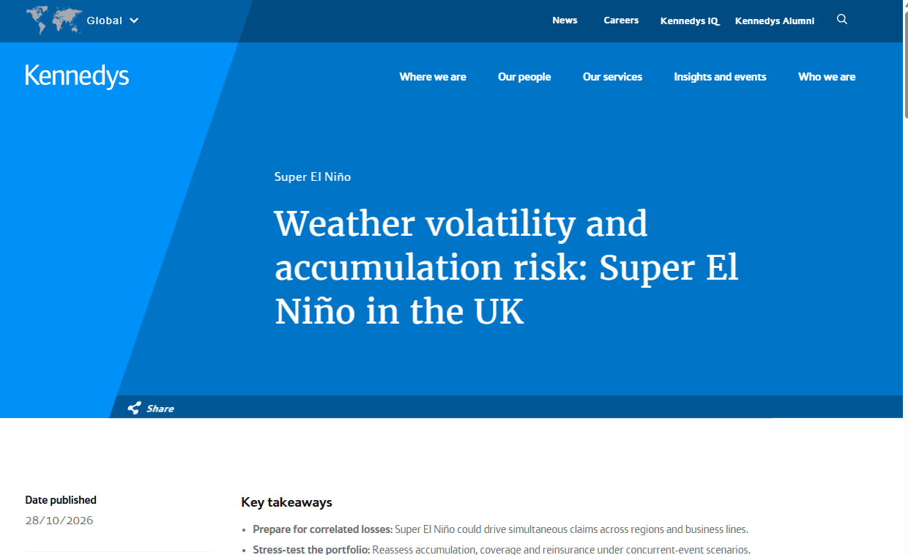

Key takeaways
- Prepare for correlated losses: Super El Niño could drive simultaneous claims across regions and business lines.
- Stress-test the portfolio: Reassess accumulation, coverage and reinsurance under concurrent-event scenarios.
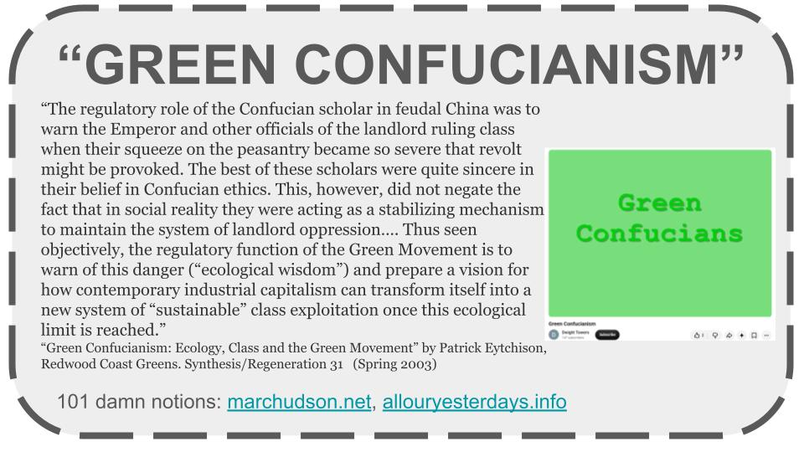
- Act early on complex claims: Address causation, aggregation and recovery strategy from the outset.
- Strengthen operational readiness: Ensure claims surge capacity, governance and resilience plans are fit for purpose.
- Capture growth opportunities: Develop climate-focused products, risk services and resilience-led propositions.

In depth
A Super El Niño is an exceptionally strong phase of the El Niño climate pattern, involving unusually warm surface waters in the central and eastern tropical Pacific. It can alter weather patterns across several regions at the same time, increasing the potential for correlated losses.

Super El Niño creates different risks across the UK
Unlike some regions where El Niño has a direct and predictable effect, the UK experiences a more complex relationship. Research generally suggests that strong El Niño events can influence atmospheric circulation patterns, increasing the likelihood of:
- Wetter autumn and winter conditions in parts of the UK and Northern Europe.
- More intense rainfall events and consequent flood risk.
- Periods of unusual warmth.
- Greater weather volatility and storm activity.
- Secondary impacts including coastal erosion, subsidence, wildfire risk following drought periods, and supply chain disruption.
For insurers, the key issue is more weather volatility and accumulation risk across multiple lines of business. For UK businesses, one of the more immediate concerns is whether a Super El Niño could contribute to wetter and stormier conditions, including more intense rainfall events, thereby increasing the risk of flood losses.

Weather volatility and accumulation risk: Super El Niño in the UK

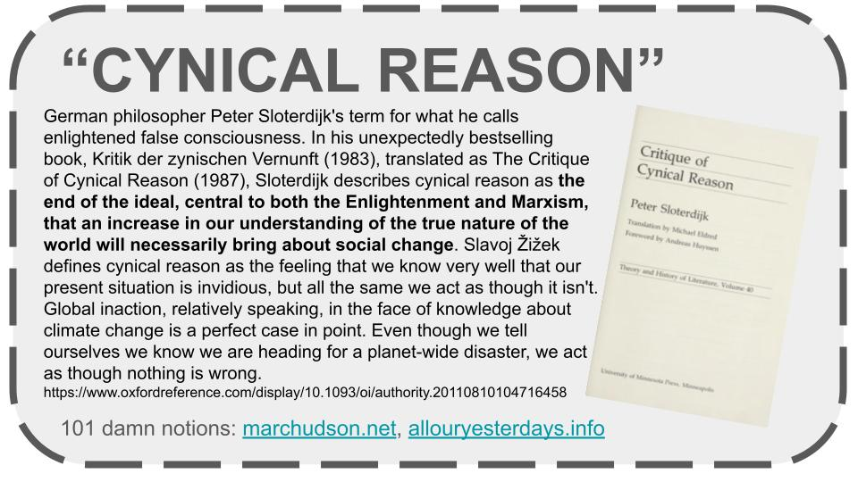
STOP PRESS
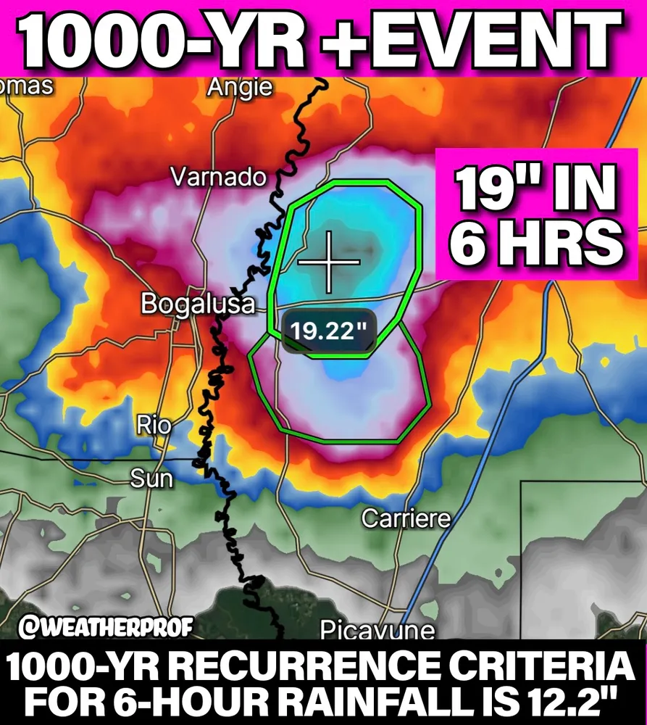
“‼️ 19” of rain in 6 hours!! ⛈️
This has to be one of the most extreme rainfalls I’ve ever seen.
12” in 3 hours, 19” in 6 hours in SW #Mississippi near the Louisiana border, north of Picayune in Pearl River County last night. This doesn’t just meet the 1000-year criteria it exceeds it by a margin that’s almost hard to comprehend.
The NWS there issued a Particularly Dangerous Situation Flash #Flood Emergency… The reason: Super El Nino’s Amplified Subtropical jet stream on top of a warmer Gulf/ warmer atmosphere. This allows for excess moisture, higher rain rates, and bigger floods. ”
https://bsky.app/profile/weatherprof.bsky.social
Links
For a FAQ see here. The comedy of El Nino (no, really) it’s a 1997 video. El Nino acronyms El Nino quotes
El Nino videos El Nino timeline up to 2025

Disclaimers
I am not a climate scientist. I am mostly collating what other people say, not pushing my own “angle”. I will get things wrong - when I do, I’ll fess up, no fuss. I will quote from “reputable” sources, but sometimes the truth is an outlandish outlier.
Blah blah information provided for lulz only. No responsibility taken for your failure to create broad-based social movements that prevent shit getting even worse and instead leading us into the pit of Sarlac.
The digest is inspired by the awe-inspiring and heart-breaking “CO2 Newsletter published by American geologist William Barbat from 1979 to 1982.